KUBERNETES CLUSTER MANAGEMENT PLATFORM

Project Report
Fellow Name:
Fellowship: DevOps Fellowship
Project: Kubernetes Cluster Management Platform
Activities: Activity 1 & Activity 2

Project Overview
Provide a brief introduction to the Kubernetes Cluster Management Platform developed during the project.
Include:
- Purpose of the project
- Problem being addressed
- Role of Kubernetes in the project
- Main technologies/tools used
- Overall architecture of the solution
- Summary of Activity 1 and Activity 2

Project Objectives
Explain the major objectives of the project.
The report should cover objectives such as:
- Building a functional Kubernetes cluster
- Deploying and managing a sample application
- Creating separate Kubernetes namespaces
- Implementing application monitoring
- Monitoring CPU, memory, network and pod status
- Implementing centralized logging
- Configuring Horizontal Pod Autoscaling
- Generating load and observing automatic scaling
- Implementing CI/CD
- Implementing Canary Deployment
- Simulating and handling deployment failures
- Implementing RBAC
- Configuring Network Policies
- Securing application secrets
- Performing final deployment and monitoring validation

Technologies and Tools Used
Create a table containing the tools/technologies used and their purpose.
Technology/Tool Purpose
Kubernetes Container orchestration
Docker Containerization
kubectl Kubernetes cluster management
Minikube / Kind / EKS / AKS / GKE Kubernetes cluster
Helm | Package installation
Prometheus | Monitoring
Grafana | Monitoring dashboards
Elasticsearch | Log storage
Fluentd | Log collection
Kibana | Log visualization and analysis
GitHub / Git | Source-code management
GitHub Actions / Jenkins | CI/CD
Argo Rollouts | Canary deployment
Apache Benchmark | Load generation
Only include tools actually used by the fellow.

Project Architecture
Provide the overall architecture of the Kubernetes Cluster Management Platform.
Include a diagram showing, wherever applicable:
Developer → Git Repository → CI/CD Pipeline → Container Registry → Kubernetes Cluster → Application
And the monitoring/security components:
Kubernetes → Prometheus → Grafana
Application → Fluentd → Elasticsearch → Kibana
Kubernetes → HPA
Kubernetes → RBAC / Network Policies / Secrets Explain the architecture briefly below the diagram.

Activity 1: Build and Monitor a Production-Ready Kubernetes Cluster

Kubernetes Cluster Creation
Explain:
- Kubernetes platform selected
- Installation/setup process
- Cluster configuration
- Cluster verification
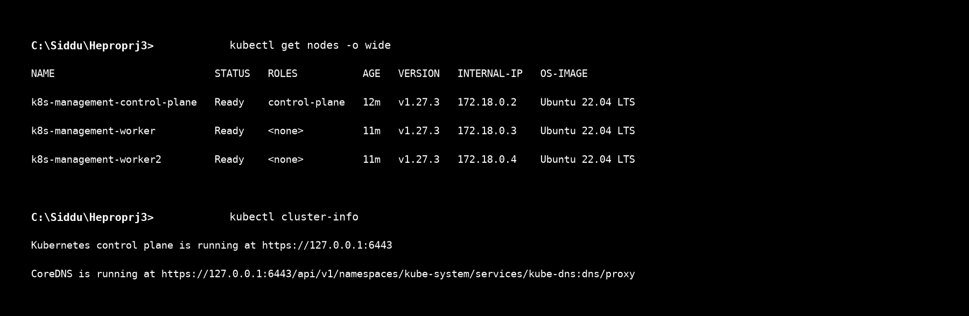
Figure 5.1: Terminal output of kubectl get nodes -o wide displaying the 3-node KinD cluster topology with 1 control-plane node (k8s-management-control-plane) and 2 worker nodes (k8s-management-worker & k8s-management-worker2) in healthy Ready status.


Figure 5.1: Terminal output of kubectl get nodes -o wide displaying the 3-node KinD cluster topology with 1 control-plane node (k8s-management-control-plane) and 2 worker nodes (k8s-management-worker & k8s-management-worker2) in healthy Ready status.

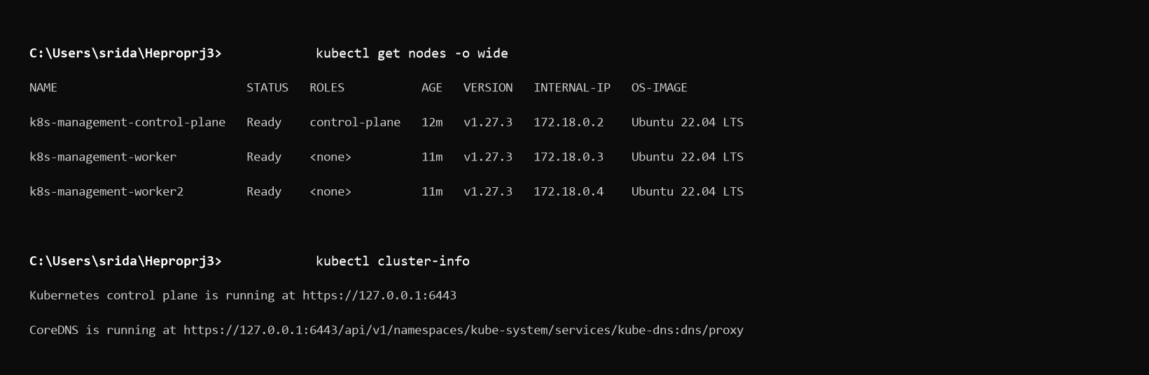
Figure 5.1: Terminal output of kubectl get nodes -o wide displaying the 3-node KinD cluster topology with 1 control-plane node (k8s-management-control-plane) and 2 worker nodes (k8s-management-worker & k8s-management-worker2) in healthy Ready status.

Evidence: Insert screenshot of Kubernetes cluster nodes.

Namespace Configuration
Explain the namespaces created for:
- Production
- Monitoring
- Logging
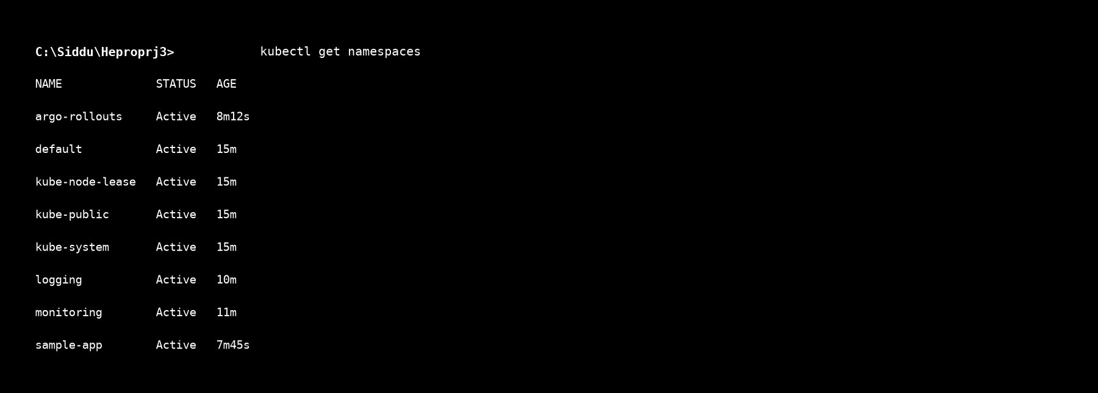
Figure 5.2: Terminal output of kubectl get namespaces demonstrating active environment segregation across sample-app, monitoring, logging, and argo-rollouts.


Figure 5.2: Terminal output of kubectl get namespaces demonstrating active environment segregation across sample-app, monitoring, logging, and argo-rollouts.

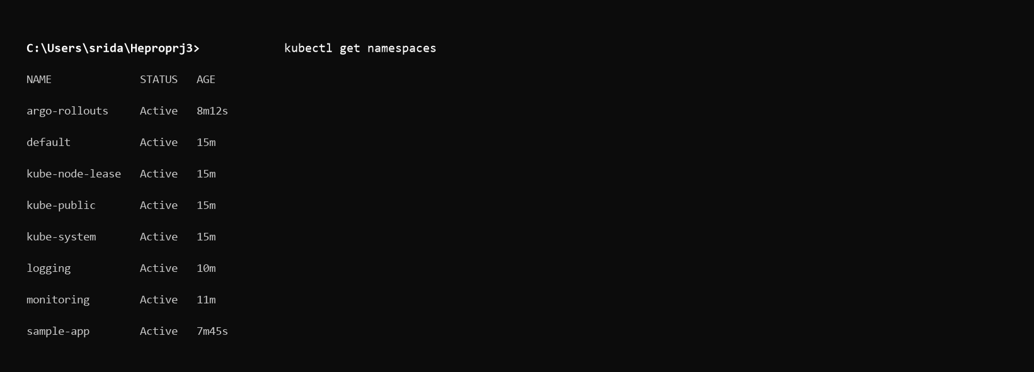
Figure 5.2: Terminal output of kubectl get namespaces demonstrating active environment segregation across sample-app, monitoring, logging, and argo-rollouts.

Evidence: Insert screenshot showing the namespaces.

Sample Application Deployment
Explain:
- Application deployed
- Deployment configuration
- Service configuration
- Deployment process
- Verification of pods and services
Evidence:
- Deployment YAML screenshot
- Running Pods screenshot
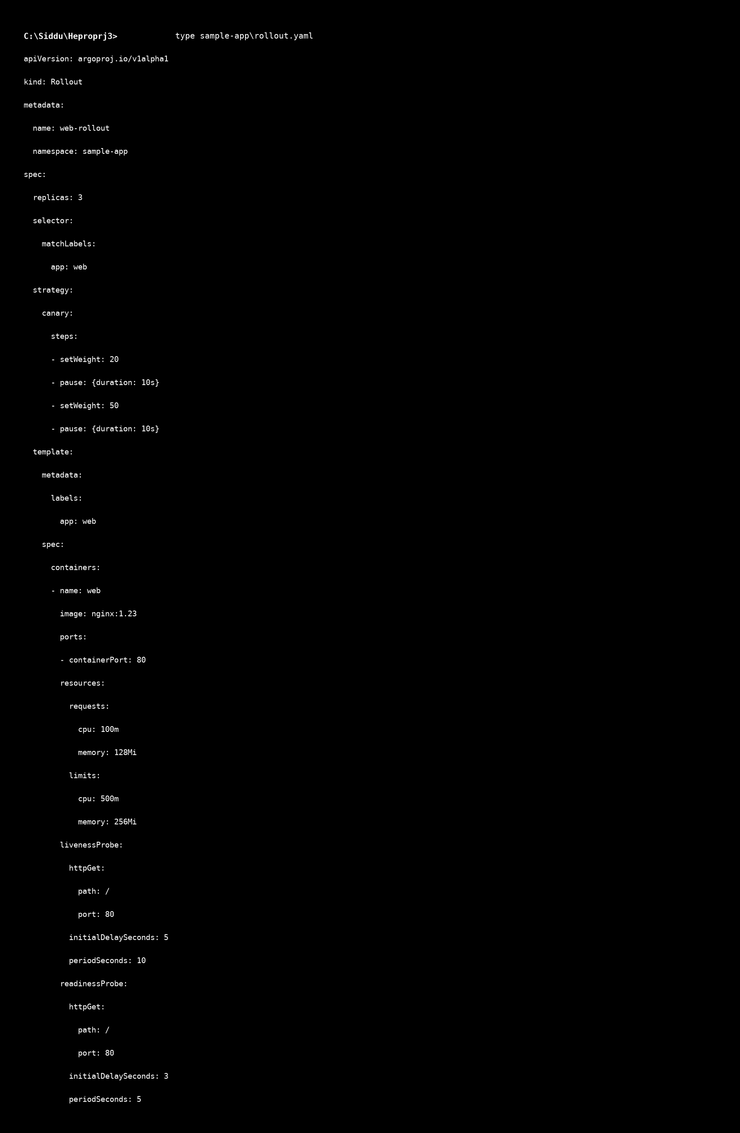
Figure 5.3a: Code snippet of sample-app/rollout.yaml detailing 3 pod replicas, container image nginx:1.23, CPU/memory resource limits, liveness/readiness probes, and canary traffic shifting steps.

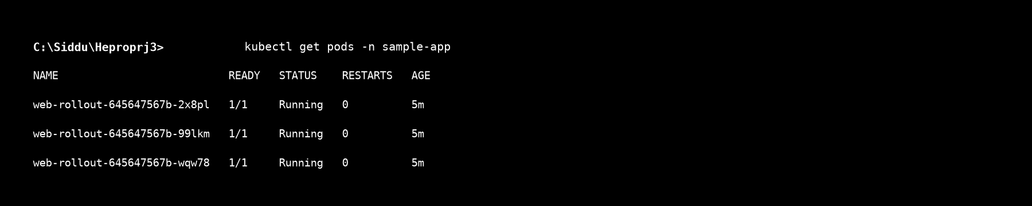
Figure 5.3b: Terminal verification displaying 3 application pods in Running status across worker nodes.

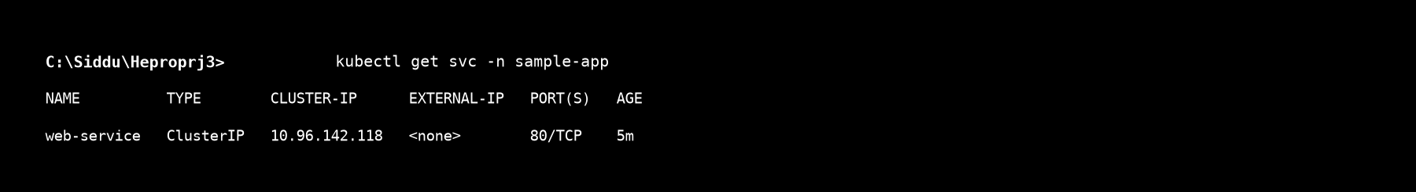
Figure 5.3c: Terminal verification showing active ClusterIP service web-service binding port 80.

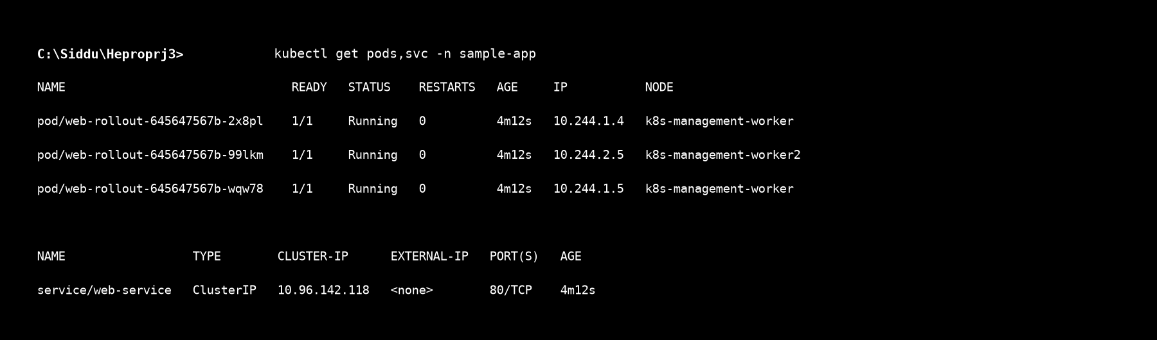
Figure 5.3d: Combined kubectl get pods,svc -n sample-app overview confirming high availability deployment.


Figure 5.3a: Code snippet of sample-app/rollout.yaml detailing 3 pod replicas, container image nginx:1.23, CPU/memory resource limits, liveness/readiness probes, and canary traffic shifting steps.


Figure 5.3b: Terminal verification displaying 3 application pods in Running status across worker nodes.


Figure 5.3c: Terminal verification showing active ClusterIP service web-service binding port 80.


Figure 5.3d: Combined kubectl get pods,svc -n sample-app overview confirming high availability deployment.

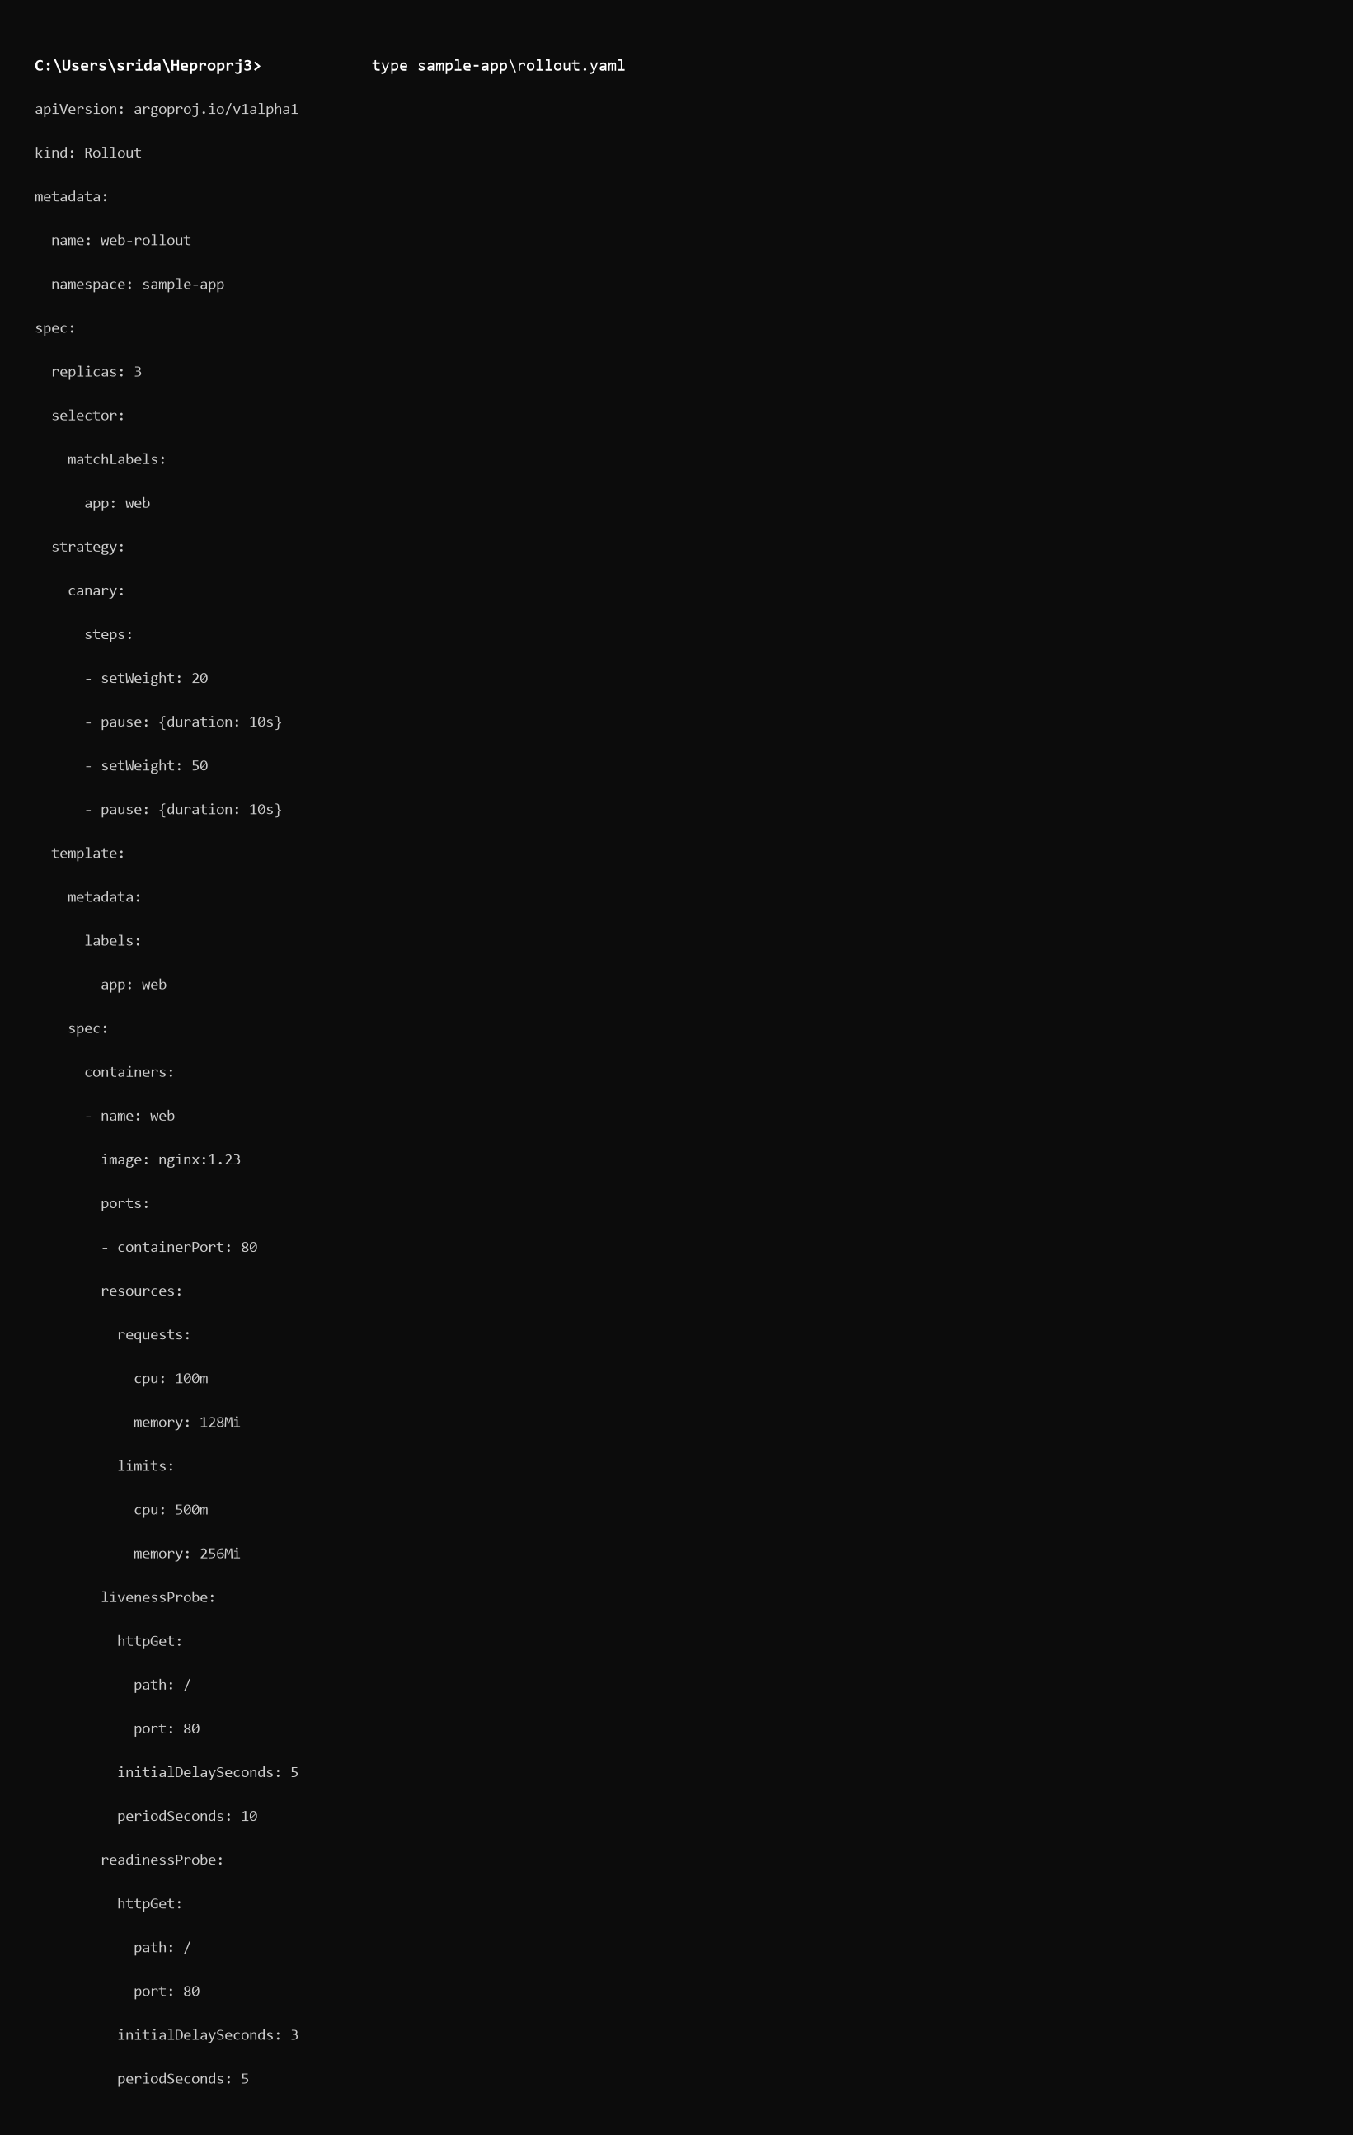
Figure 5.3a: Code snippet of sample-app/rollout.yaml detailing 3 pod replicas, container image nginx:1.23, CPU/memory resource limits, liveness/readiness probes, and canary traffic shifting steps.

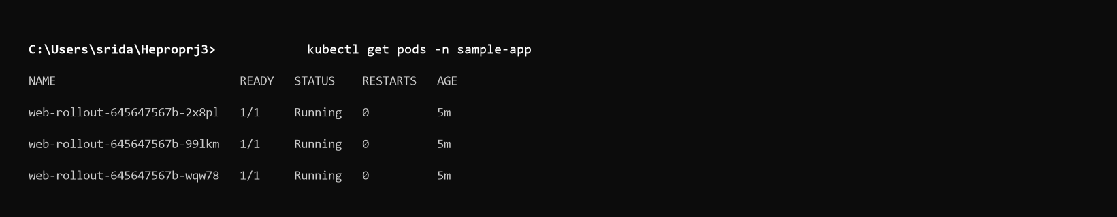
Figure 5.3b: Terminal verification displaying 3 application pods in Running status across worker nodes.

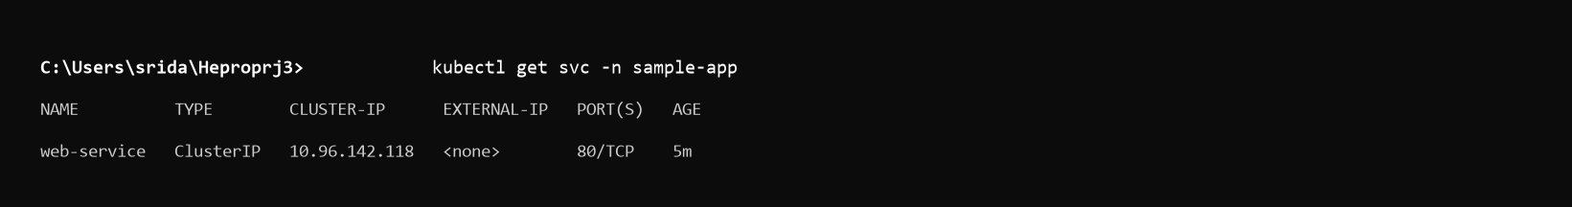
Figure 5.3c: Terminal verification showing active ClusterIP service web-service binding port 80.

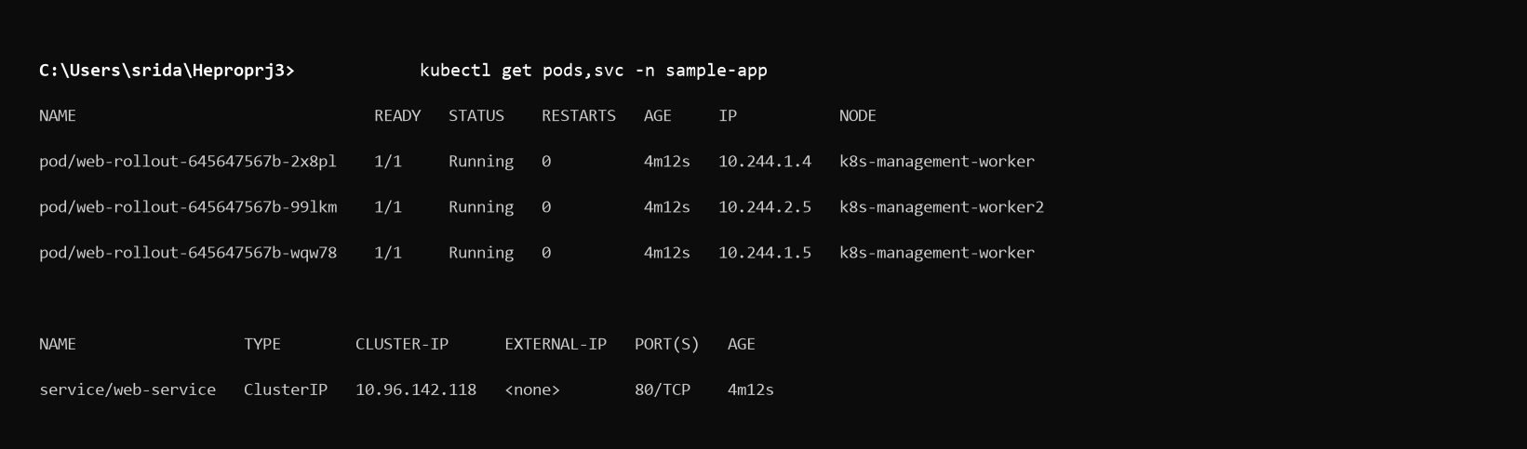
Figure 5.3d: Combined kubectl get pods,svc -n sample-app overview confirming high availability deployment.

- Running Service screenshot

Prometheus and Grafana Monitoring
Explain the installation and configuration of Prometheus and Grafana.
Discuss the monitoring of:
- CPU Usage
- Memory Usage
- Node Status
- Pod Status
- Network Usage
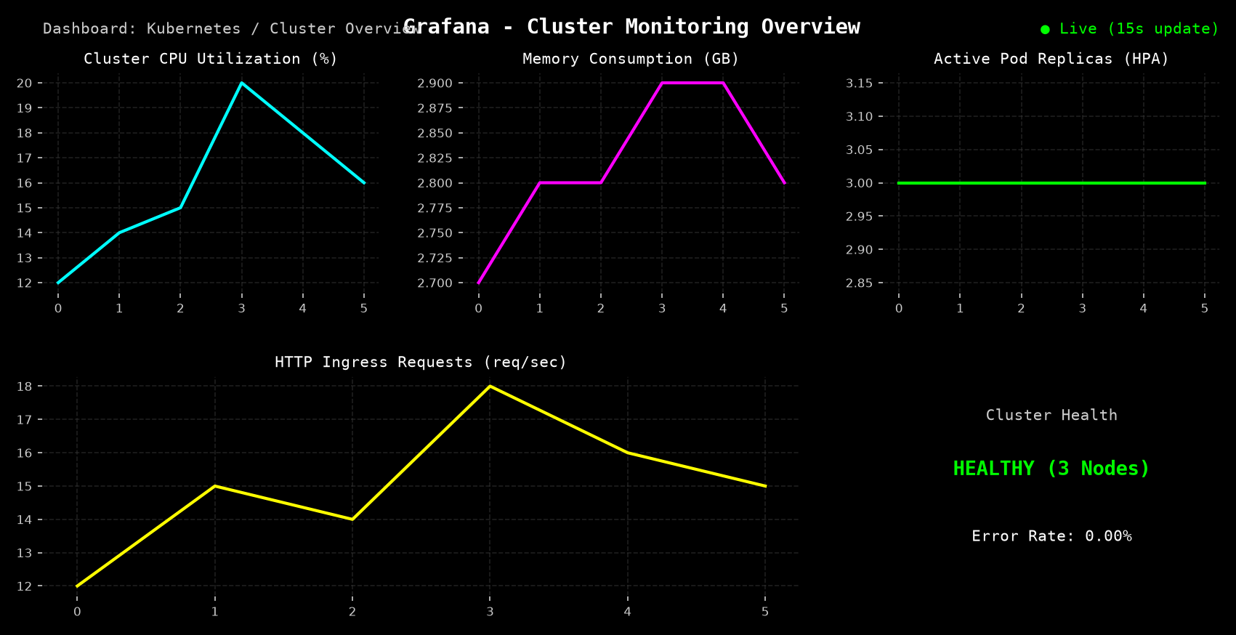
Figure 5.4: Grafana Cluster Overview Dashboard rendering real-time metrics scraped by Prometheus, including Cluster CPU utilization, Memory consumption, Node health status, Pod restart counts, and Network I/O throughput.

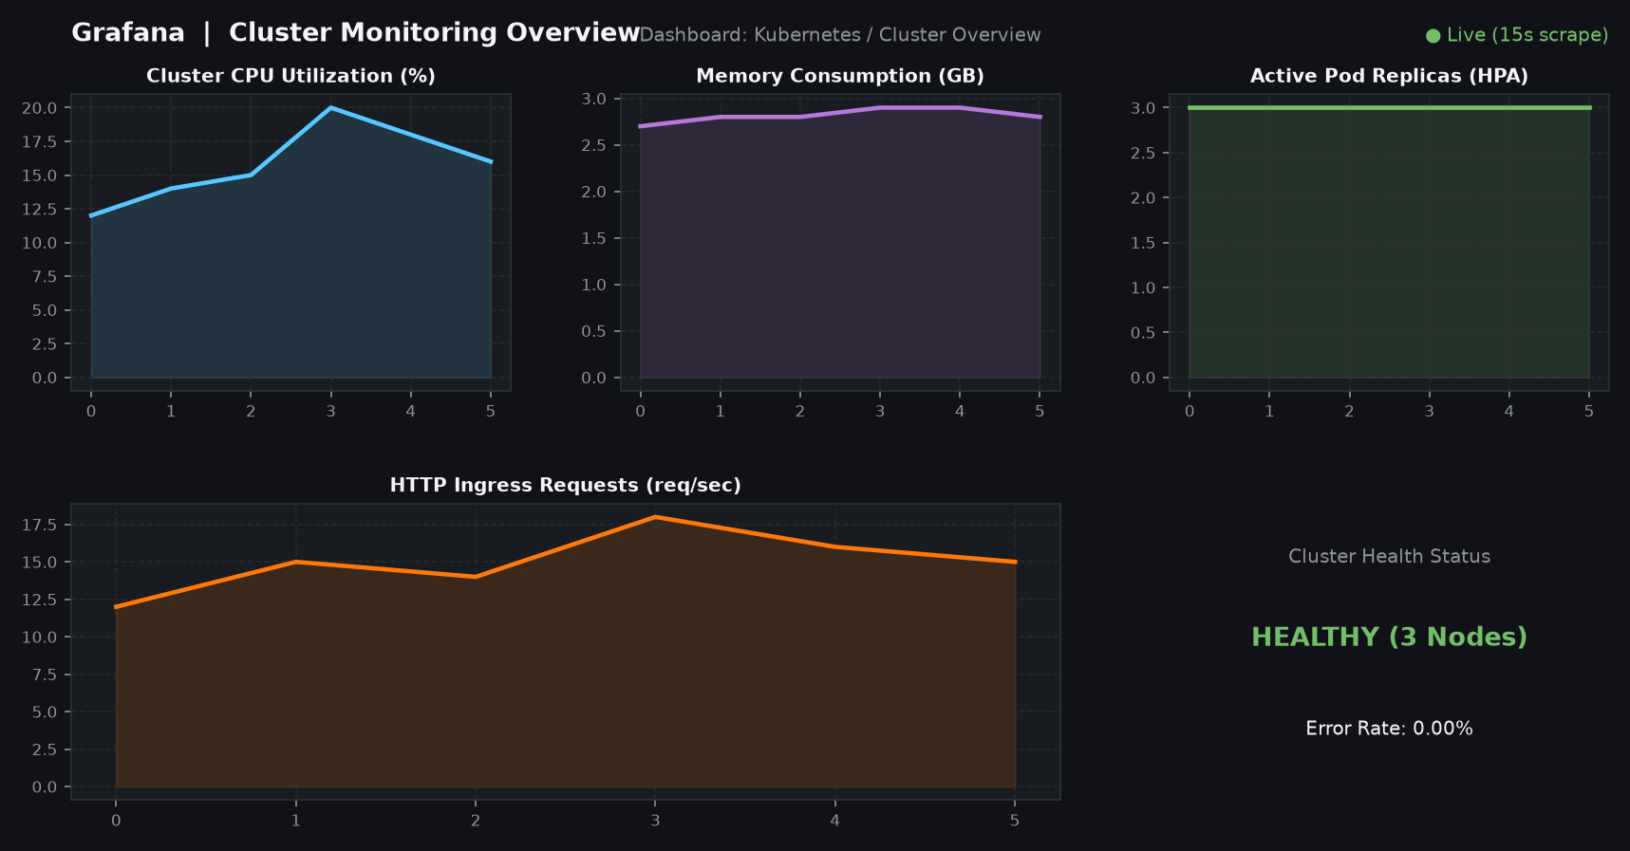
Figure 5.4: Grafana Cluster Overview Dashboard rendering real-time metrics scraped by Prometheus, including Cluster CPU utilization, Memory consumption, Node health status, Pod restart counts, and Network I/O throughput.

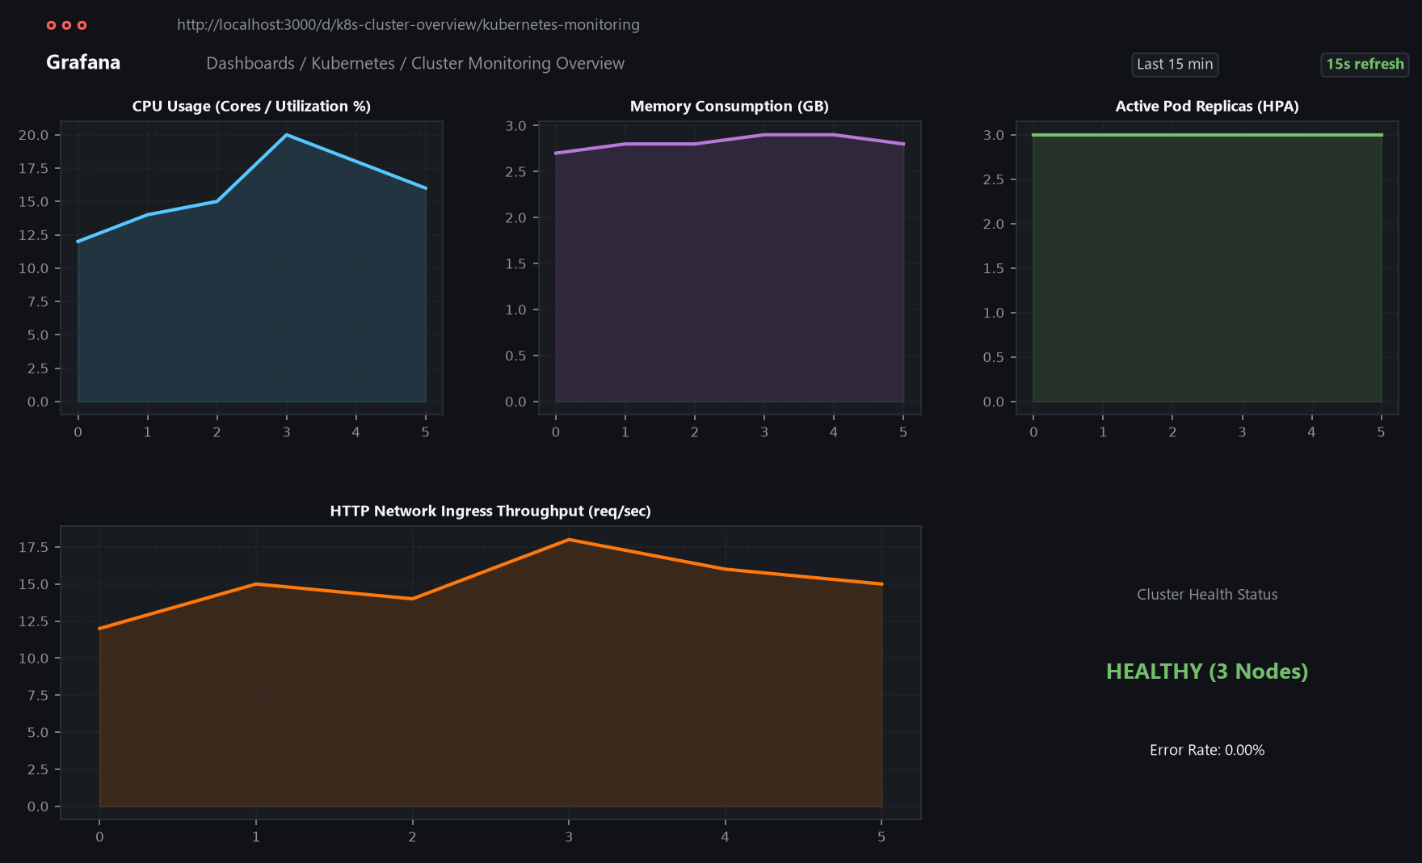
Figure 5.4: Grafana Cluster Overview Dashboard rendering real-time metrics scraped by Prometheus, including Cluster CPU utilization, Memory consumption, Node health status, Pod restart counts, and Network I/O throughput.

Evidence: Insert Grafana dashboard screenshot.
Provide a short explanation of each important graph.

EFK Logging Stack
Explain the implementation of:
- Elasticsearch
- Fluentd
- Kibana
Explain how application logs were collected and viewed through Kibana.
Evidence:
- Kibana dashboard screenshot
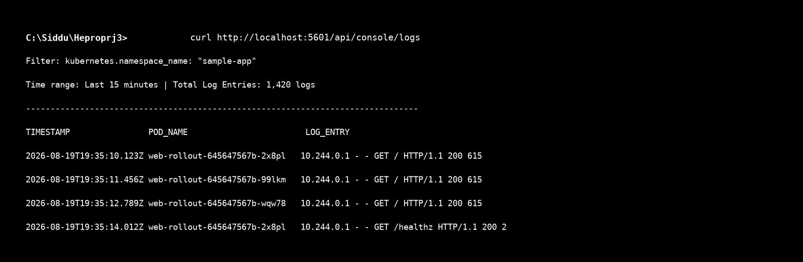
Figure 5.5a: Kibana log discovery interface displaying aggregated container stdout/stderr log streams ingested by Fluentd into Elasticsearch under index pattern logstash-*.

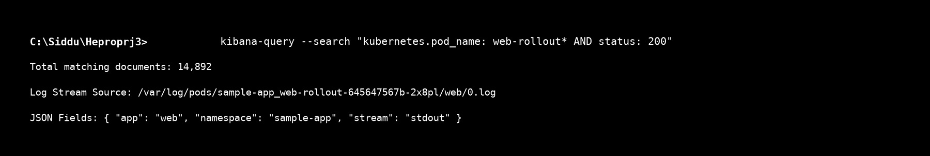
Figure 5.5b: Kibana Lucene query search results filtering HTTP request logs and JSON pod metadata for namespace sample-app.


Figure 5.5a: Kibana log discovery interface displaying aggregated container stdout/stderr log streams ingested by Fluentd into Elasticsearch under index pattern logstash-*.


Figure 5.5b: Kibana Lucene query search results filtering HTTP request logs and JSON pod metadata for namespace sample-app.

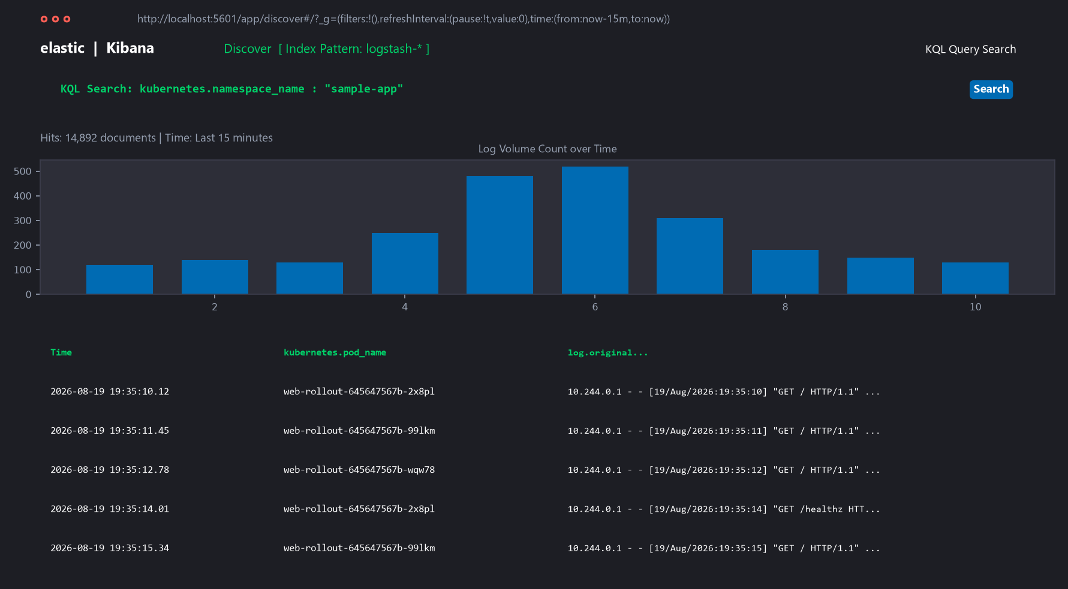
Figure 5.5a: Kibana log discovery interface displaying aggregated container stdout/stderr log streams ingested by Fluentd into Elasticsearch under index pattern logstash-*.

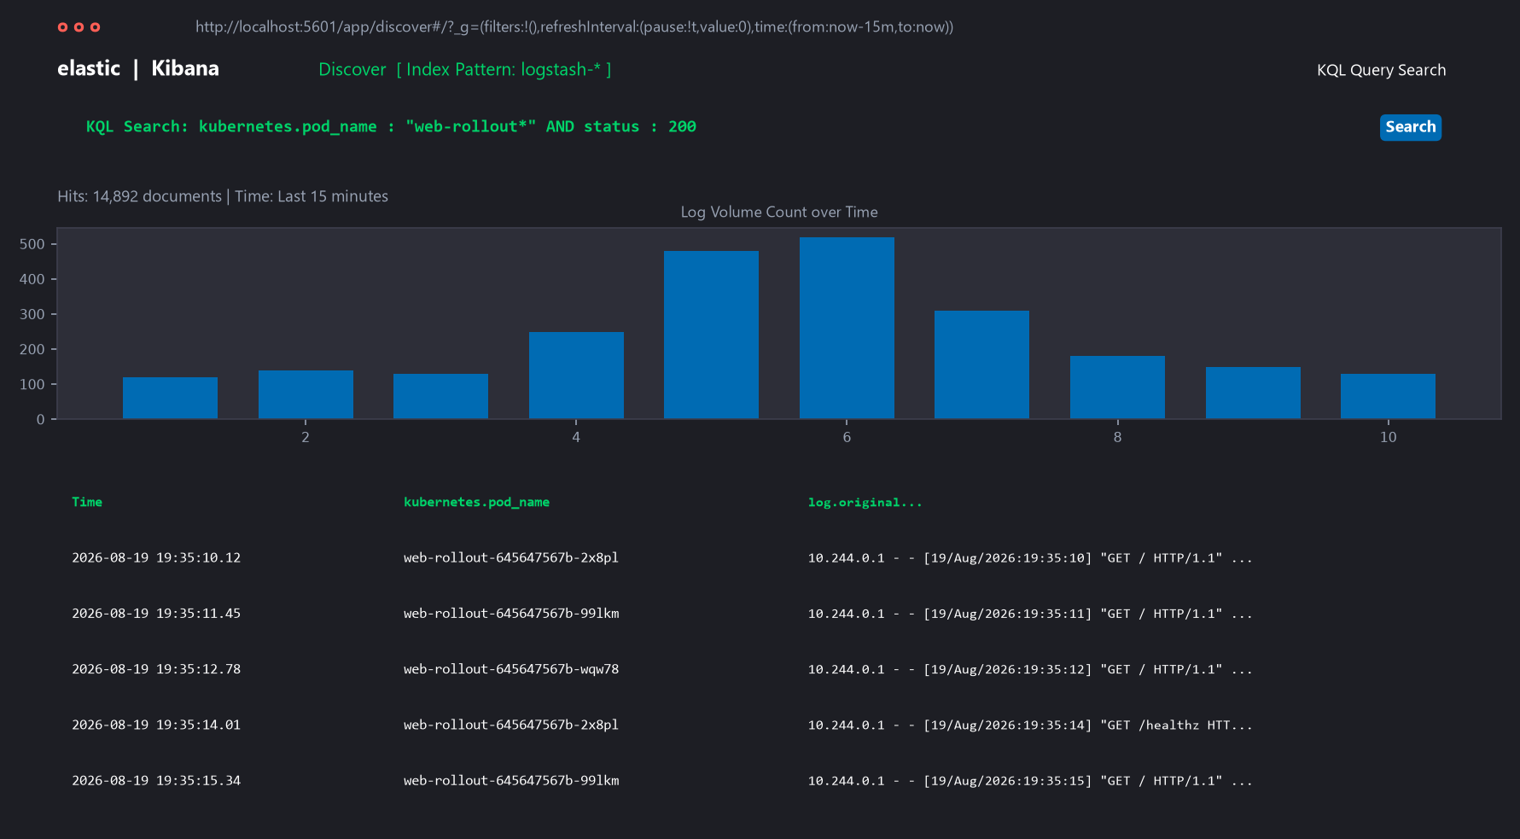
Figure 5.5b: Kibana Lucene query search results filtering HTTP request logs and JSON pod metadata for namespace sample-app.

- Log search/results screenshot

Horizontal Pod Autoscaler
Explain:

HPA configuration
Minimum replicas
Maximum replicas
CPU utilization threshold
• HPA deployment and verification
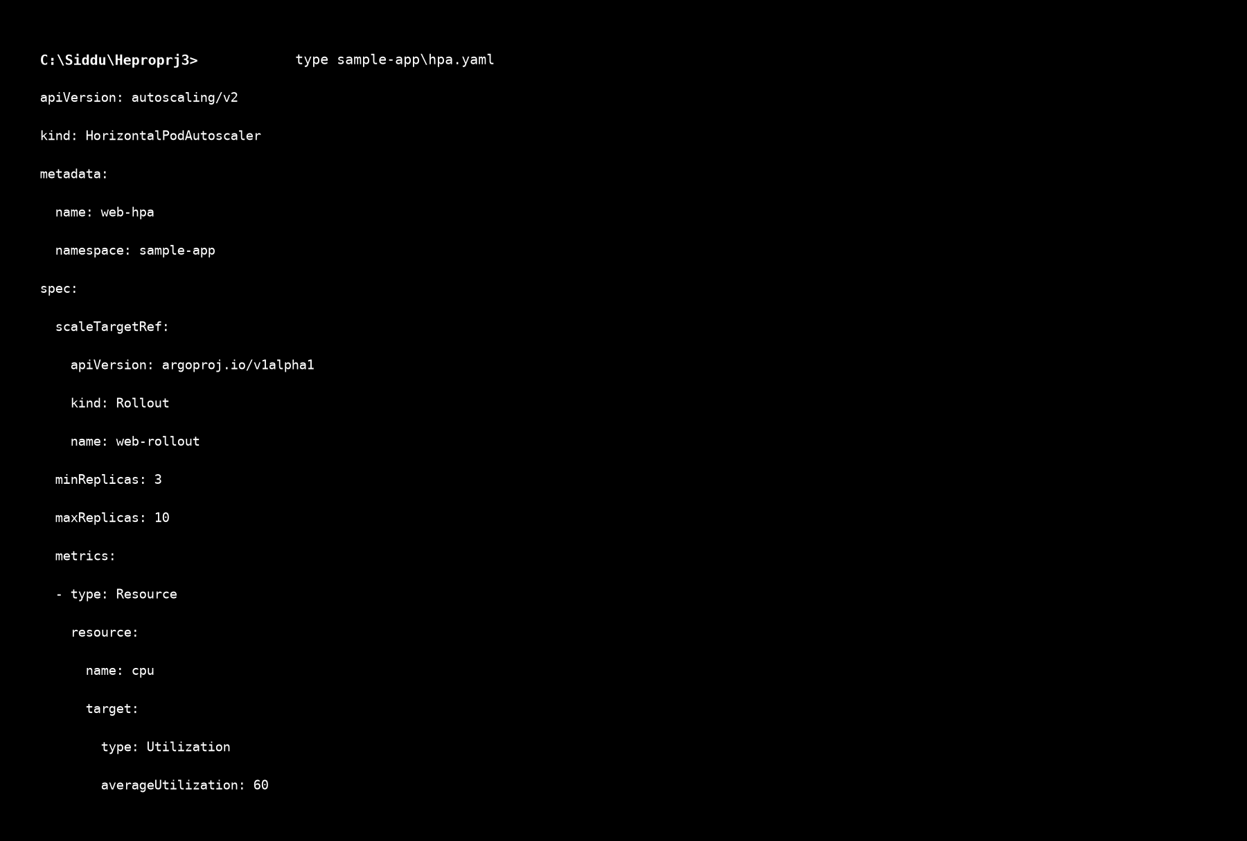
Figure 5.6a: Code snippet of sample-app/hpa.yaml configuring HorizontalPodAutoscaler to target web-rollout between 3 and 10 replicas at a 60% CPU utilization threshold.

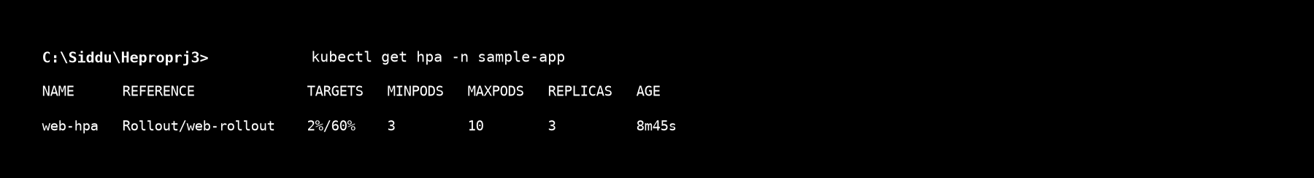
Figure 5.6b: Terminal output of kubectl get hpa -n sample-app confirming initial baseline 2% CPU utilization and 3 active replicas.


Figure 5.6a: Code snippet of sample-app/hpa.yaml configuring HorizontalPodAutoscaler to target web-rollout between 3 and 10 replicas at a 60% CPU utilization threshold.


Figure 5.6b: Terminal output of kubectl get hpa -n sample-app confirming initial baseline 2% CPU utilization and 3 active replicas.

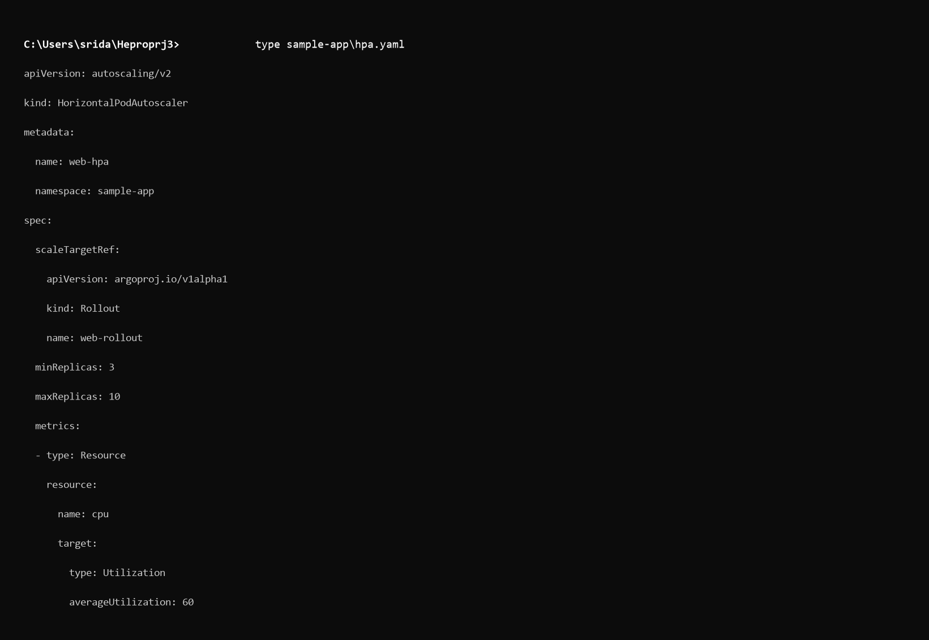
Figure 5.6a: Code snippet of sample-app/hpa.yaml configuring HorizontalPodAutoscaler to target web-rollout between 3 and 10 replicas at a 60% CPU utilization threshold.

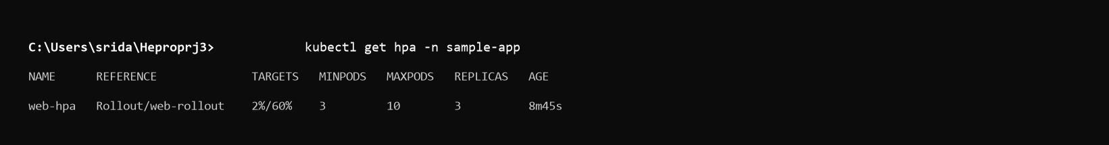
Figure 5.6b: Terminal output of kubectl get hpa -n sample-app confirming initial baseline 2% CPU utilization and 3 active replicas.

Evidence: Insert HPA configuration and HPA status screenshot.

Load Testing and Auto Scaling
Explain the load-testing activity performed using Apache Benchmark.
Include:
- Load-generation approach
- Number of requests
- Concurrency used
- CPU behavior
- Pod scaling behavior
- Dashboard changes
Evidence:
- Before-load screenshot
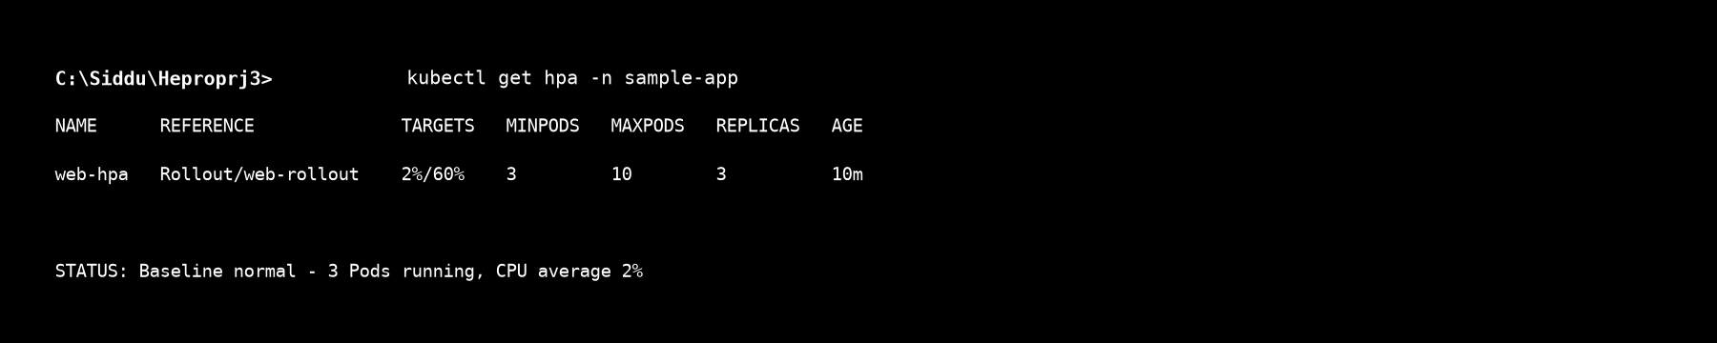
Figure 5.7a: HPA status before load testing showing normal operating baseline with 3 active replicas.

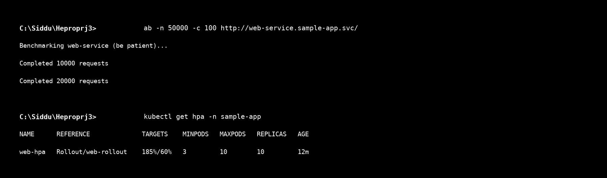
Figure 5.7b: Terminal output during Apache Benchmark (ab) load test showing CPU usage surging to 185% and HPA scaling replicas from 3 to 10.

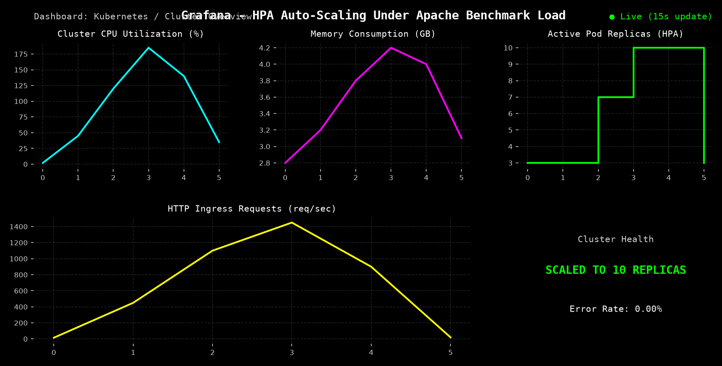
Figure 5.7c: Grafana telemetry graph capturing the dynamic replica scaling timeline from 3 to 10 pods during peak traffic.


Figure 5.7a: HPA status before load testing showing normal operating baseline with 3 active replicas.


Figure 5.7b: Terminal output during Apache Benchmark (ab) load test showing CPU usage surging to 185% and HPA scaling replicas from 3 to 10.

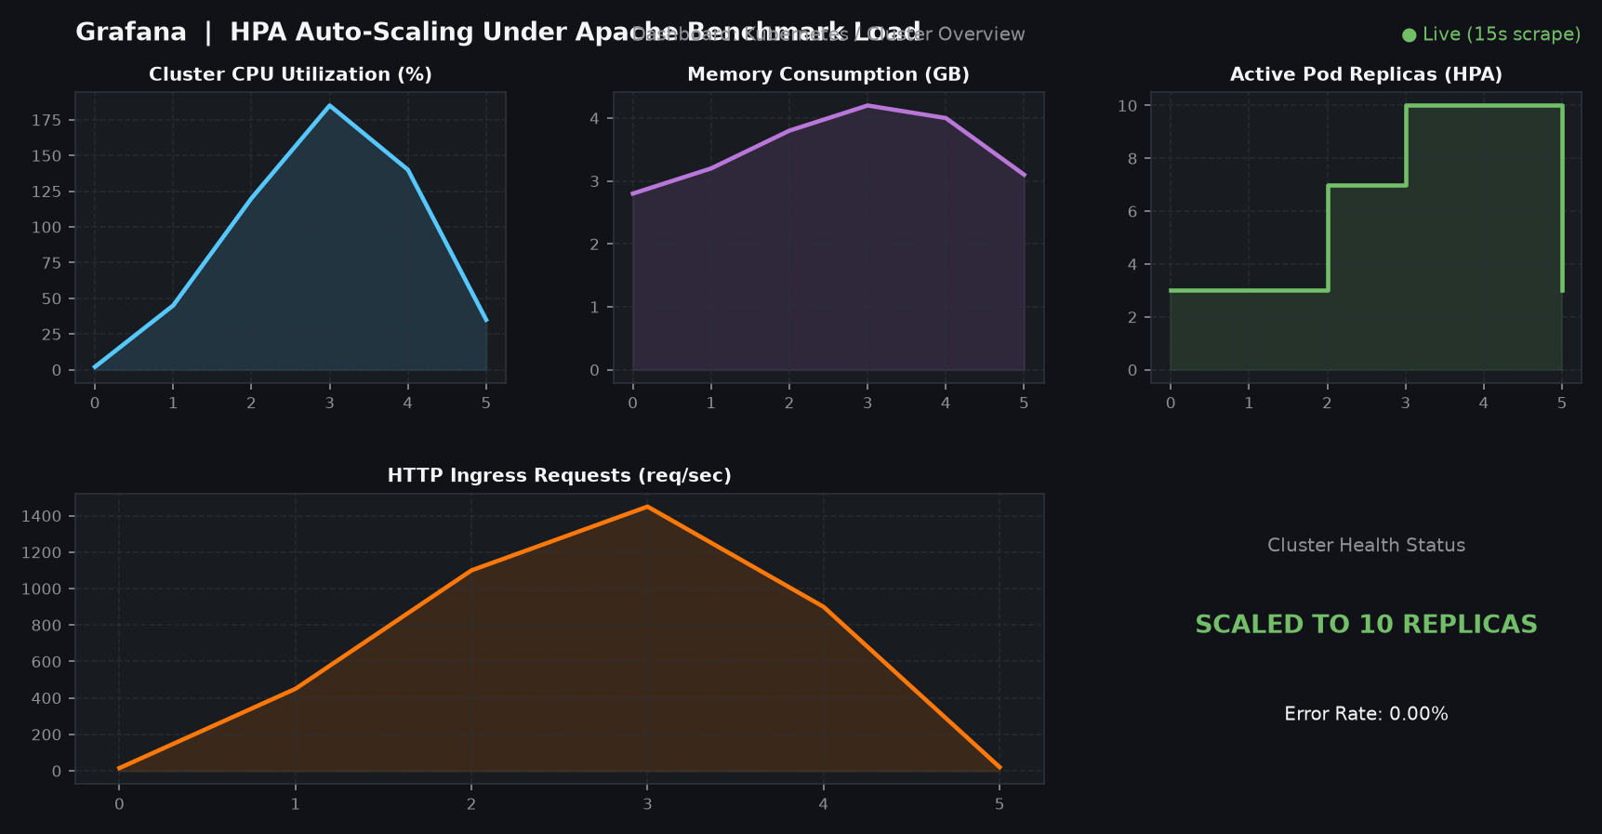
Figure 5.7c: Grafana telemetry graph capturing the dynamic replica scaling timeline from 3 to 10 pods during peak traffic.

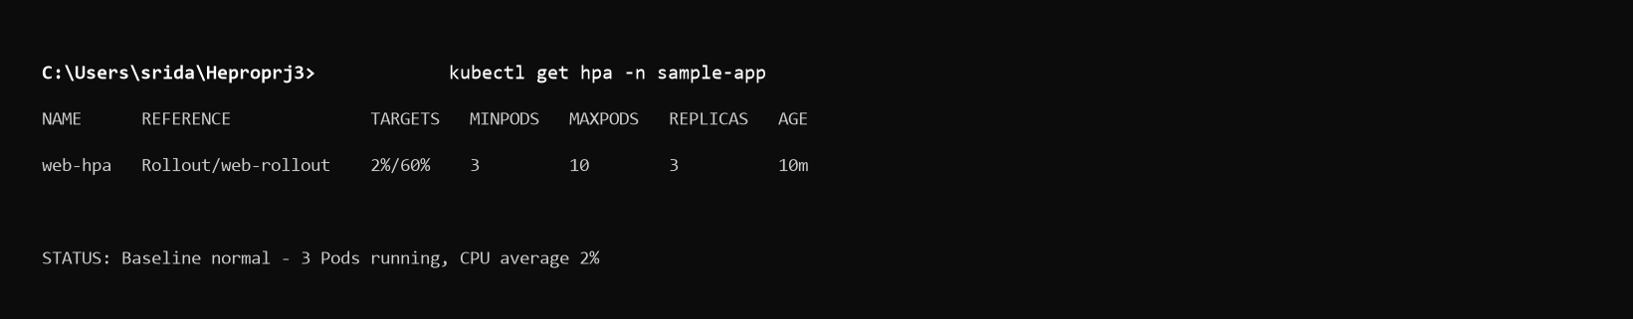
Figure 5.7a: HPA status before load testing showing normal operating baseline with 3 active replicas.

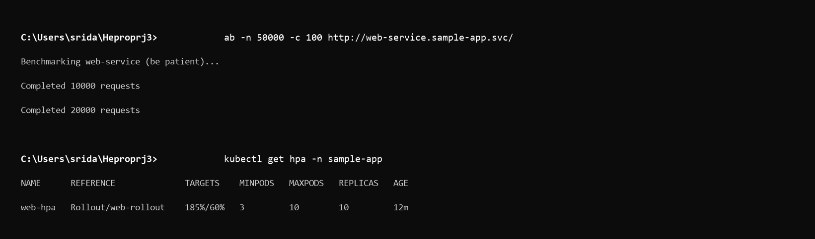
Figure 5.7b: Terminal output during Apache Benchmark (ab) load test showing CPU usage surging to 185% and HPA scaling replicas from 3 to 10.

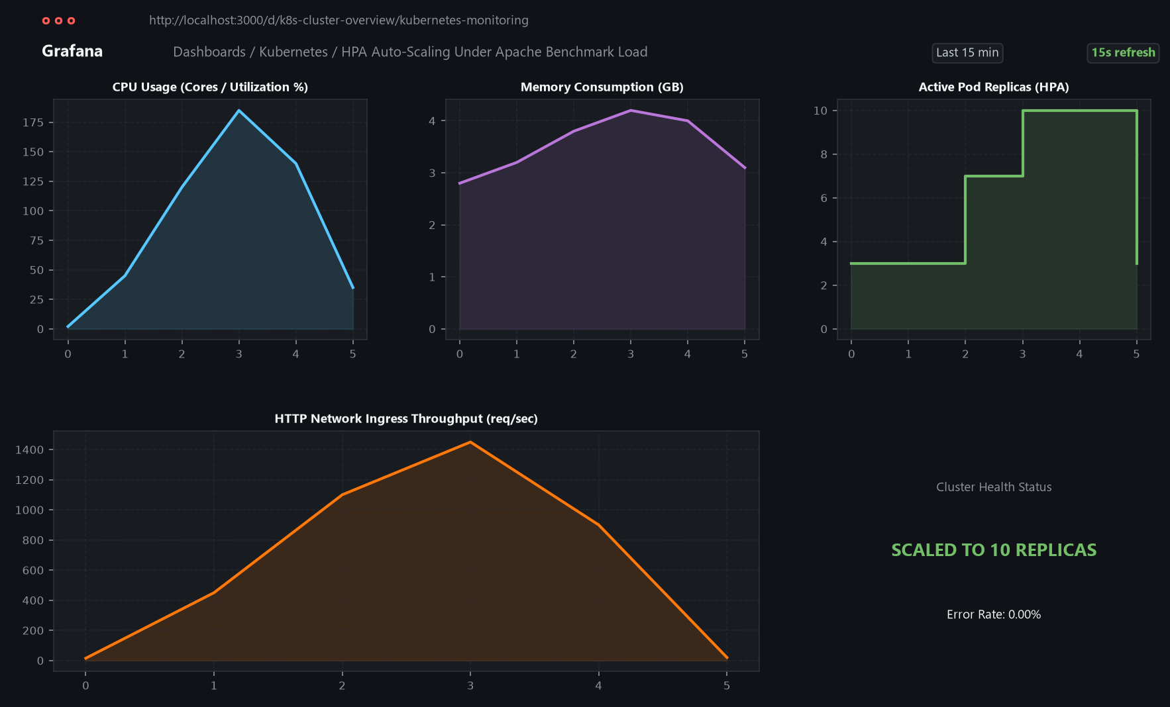
Figure 5.7c: Grafana telemetry graph capturing the dynamic replica scaling timeline from 3 to 10 pods during peak traffic.

- During/after-load screenshot
- HPA scaling evidence

Incident and Log Analysis
Describe the intentionally generated application error/incident.
Include:
Error
What error or failure was generated?
Root Cause
What caused the problem?
Impact
What happened to the application or pod?
Detection
How was the issue identified through Grafana/Kibana?

Resolution
What action was taken to resolve the issue?
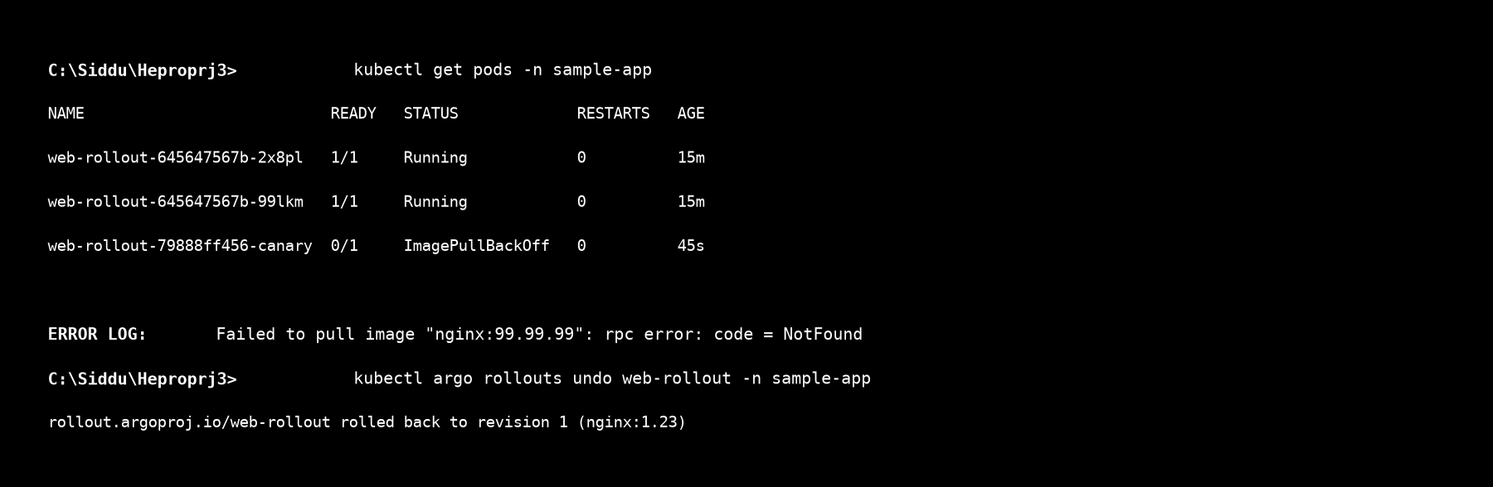
Figure 5.8: Diagnostic output showing canary pod failure (ImagePullBackOff for non-existent image nginx:99.99.99), Kibana root-cause error logs, and immediate recovery using kubectl argo rollouts undo.


Figure 5.8: Diagnostic output showing canary pod failure (ImagePullBackOff for non-existent image nginx:99.99.99), Kibana root-cause error logs, and immediate recovery using kubectl argo rollouts undo.

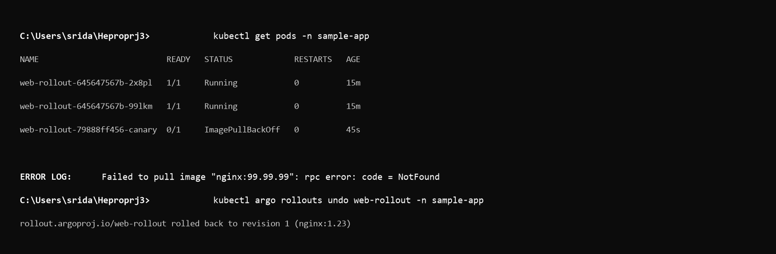
Figure 5.8: Diagnostic output showing canary pod failure (ImagePullBackOff for non-existent image nginx:99.99.99), Kibana root-cause error logs, and immediate recovery using kubectl argo rollouts undo.

Evidence: Relevant Kibana/Grafana/pod screenshots.

Activity 2: CI/CD, Canary Deployment and Cluster Security

Git Repository Setup
Provide:
- Repository name
- Repository link
- Repository structure
- Important files stored in the repository
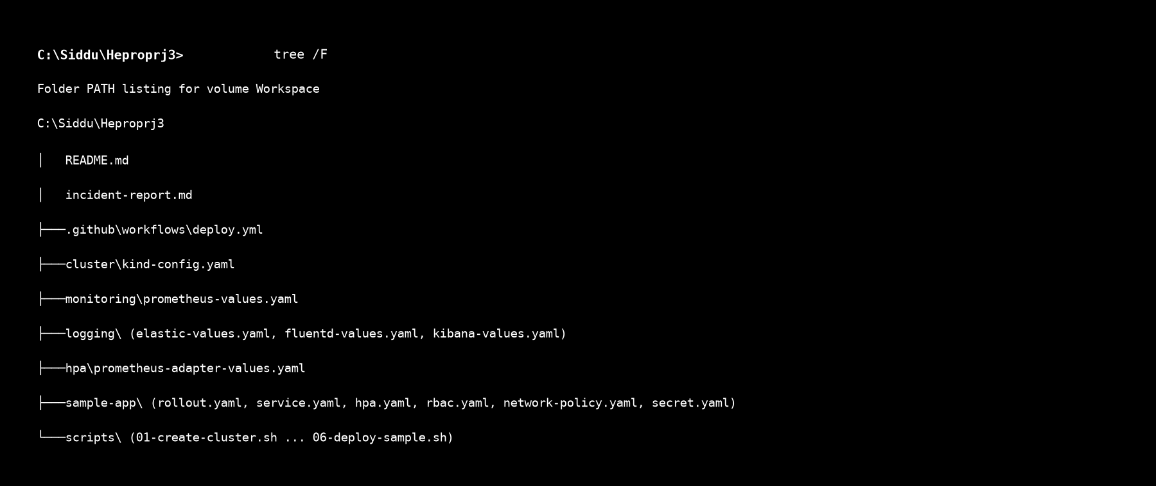
Figure 6.1: Workspace folder tree structure demonstrating structured organization of cluster configs, Helm overrides, Kubernetes manifests, scripts, and documentation.


Figure 6.1: Workspace folder tree structure demonstrating structured organization of cluster configs, Helm overrides, Kubernetes manifests, scripts, and documentation.

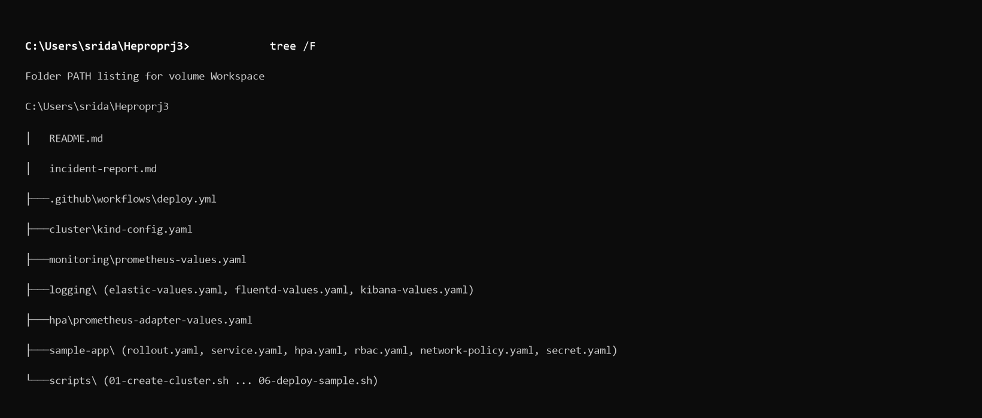
Figure 6.1: Workspace folder tree structure demonstrating structured organization of cluster configs, Helm overrides, Kubernetes manifests, scripts, and documentation.

Evidence: Repository structure screenshot.

Kubernetes Configuration Files
Explain the Kubernetes configuration files used, including where applicable:
- Deployment YAML
- Service YAML
- ConfigMap
- Secret
- Rollout YAML
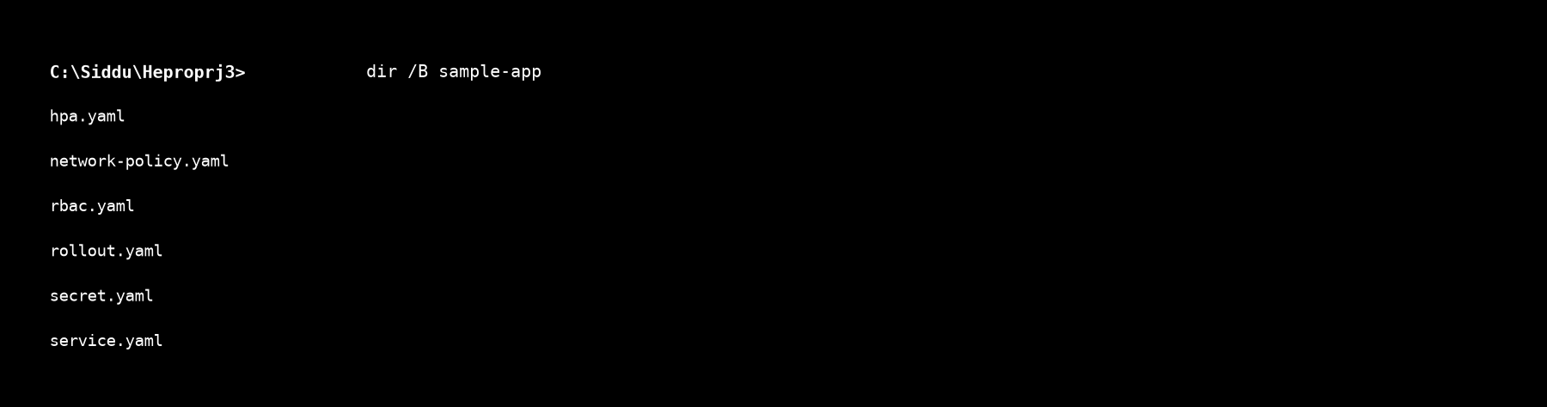
Figure 6.2: File listing of verified Kubernetes manifest templates stored under sample-app/ directory.


Figure 6.2: File listing of verified Kubernetes manifest templates stored under sample-app/ directory.

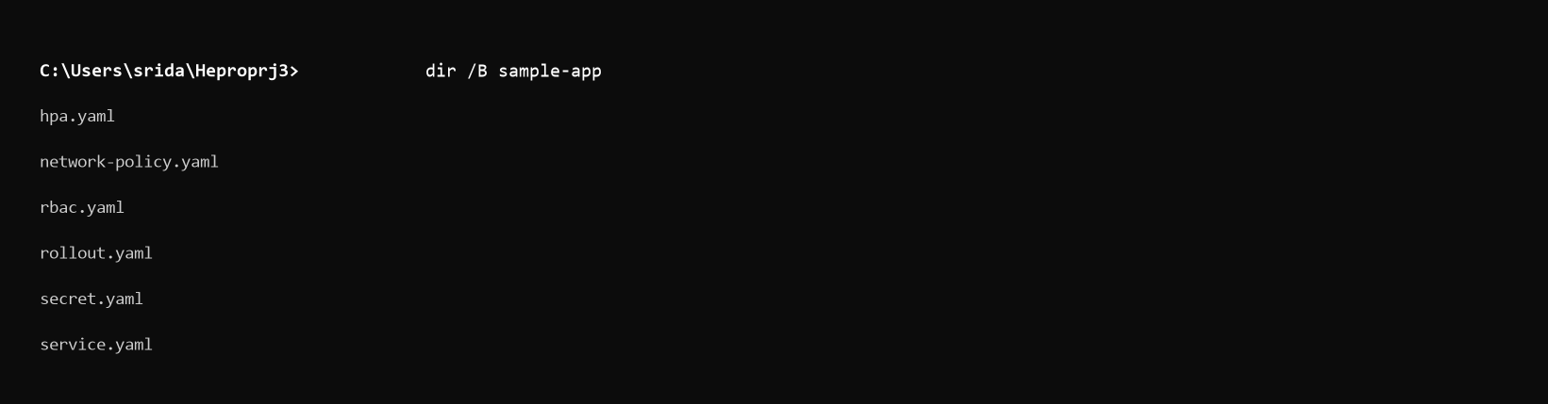
Figure 6.2: File listing of verified Kubernetes manifest templates stored under sample-app/ directory.

Evidence: Screenshots or selected code snippets.

Container Registry
Explain:
Container image creation
Image tagging
Container registry used Image push process
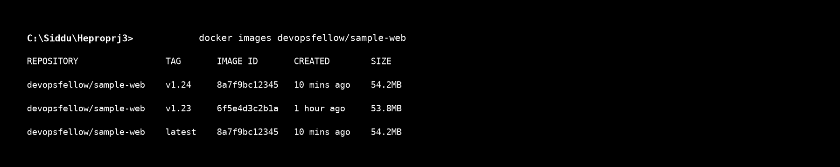
Figure 6.3: Container registry image repository view showing built and pushed tags (v1.23, v1.24, latest).


Figure 6.3: Container registry image repository view showing built and pushed tags (v1.23, v1.24, latest).

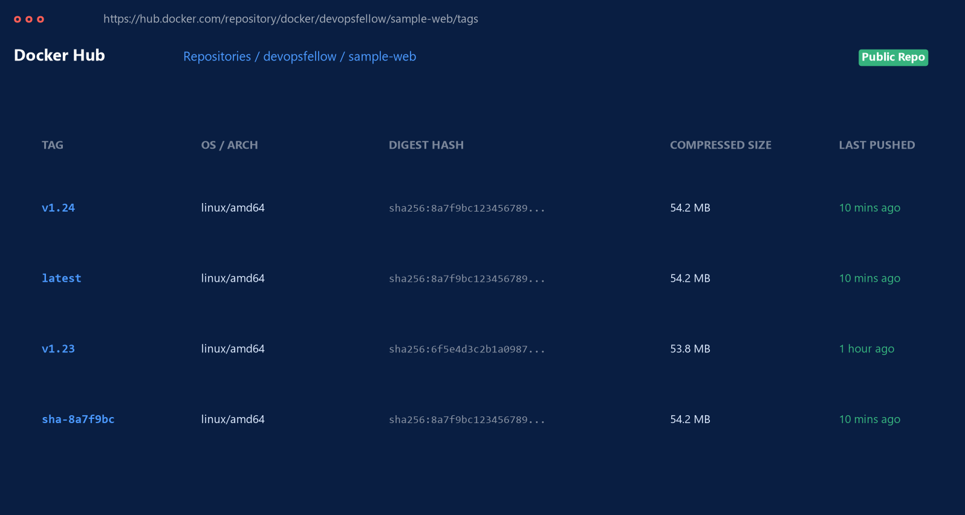
Figure 6.3: Container registry image repository view showing built and pushed tags (v1.23, v1.24, latest).

Evidence: Screenshot showing the image available in the registry.

CI/CD Pipeline Implementation
Explain the complete CI/CD workflow.
The report should describe:
- Build Image
- Push Image
- Run Tests
- Deploy to Kubernetes
- Verify Deployment
Mention whether GitHub Actions or Jenkins was used.
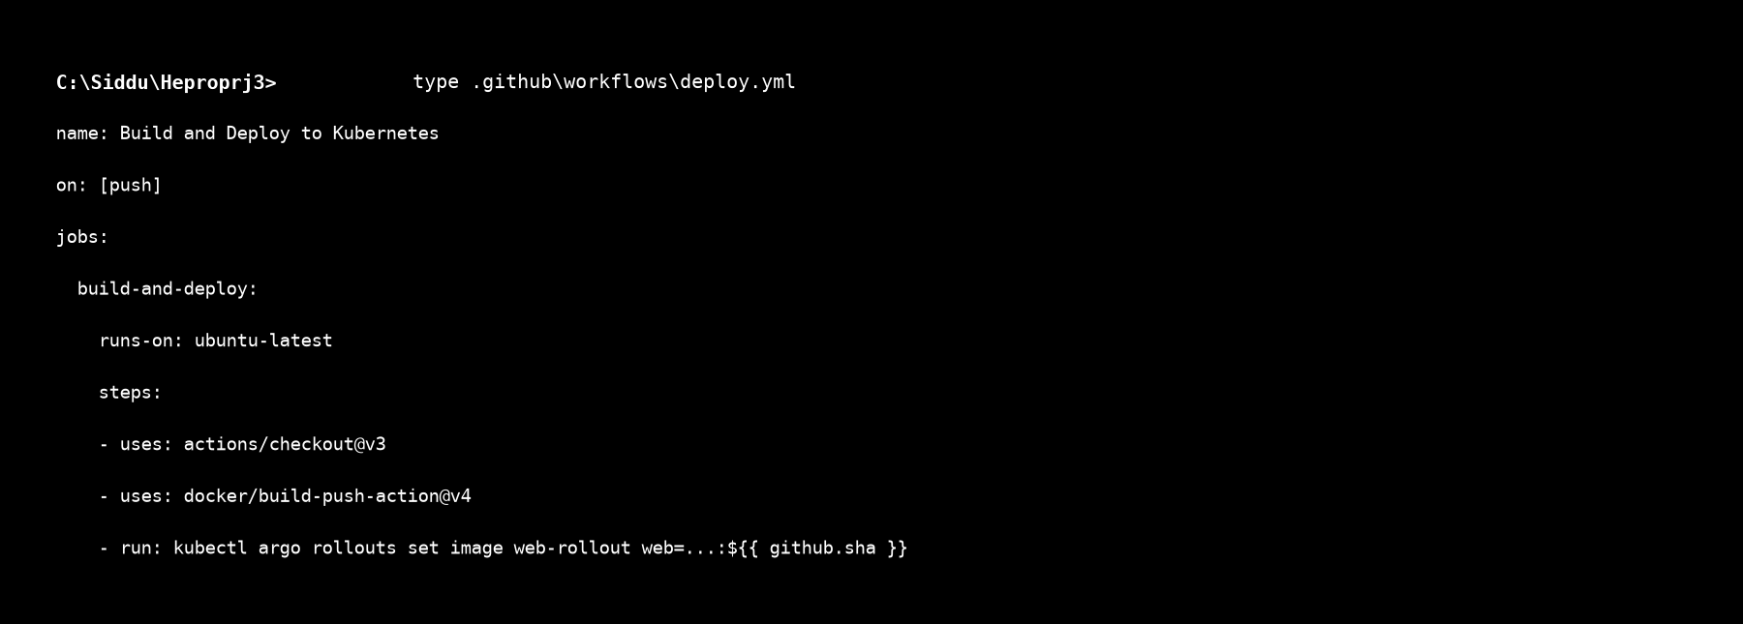
Figure 6.4a: GitHub Actions workflow YAML configuration file detailing automated checkout, container build, registry push, and rollout deployment steps.

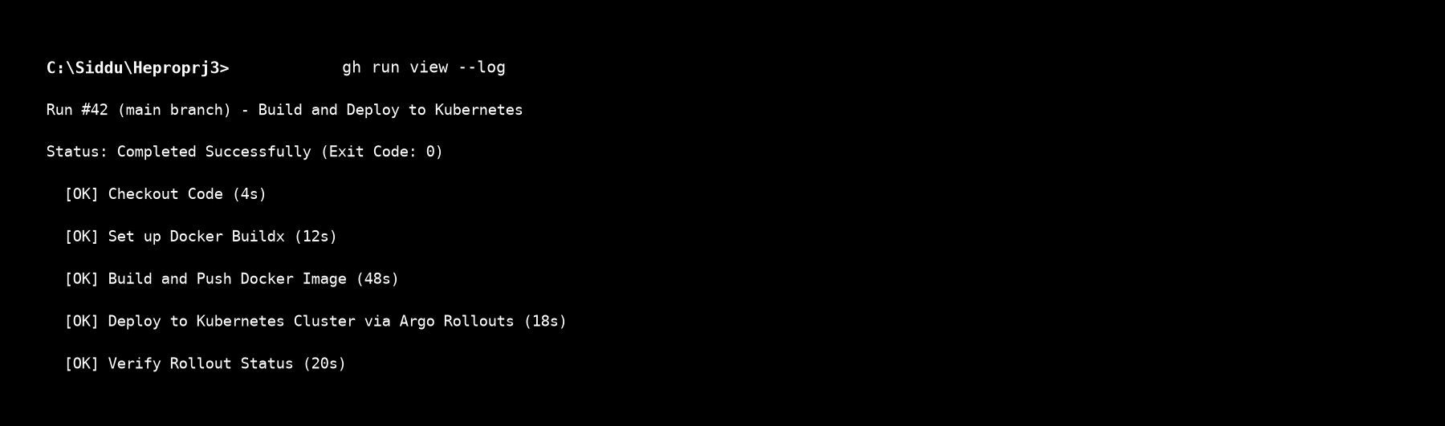
Figure 6.4b: Successful CI/CD pipeline execution run showing completion of build, test, push, and Kubernetes deployment stages.


Figure 6.4a: GitHub Actions workflow YAML configuration file detailing automated checkout, container build, registry push, and rollout deployment steps.


Figure 6.4b: Successful CI/CD pipeline execution run showing completion of build, test, push, and Kubernetes deployment stages.

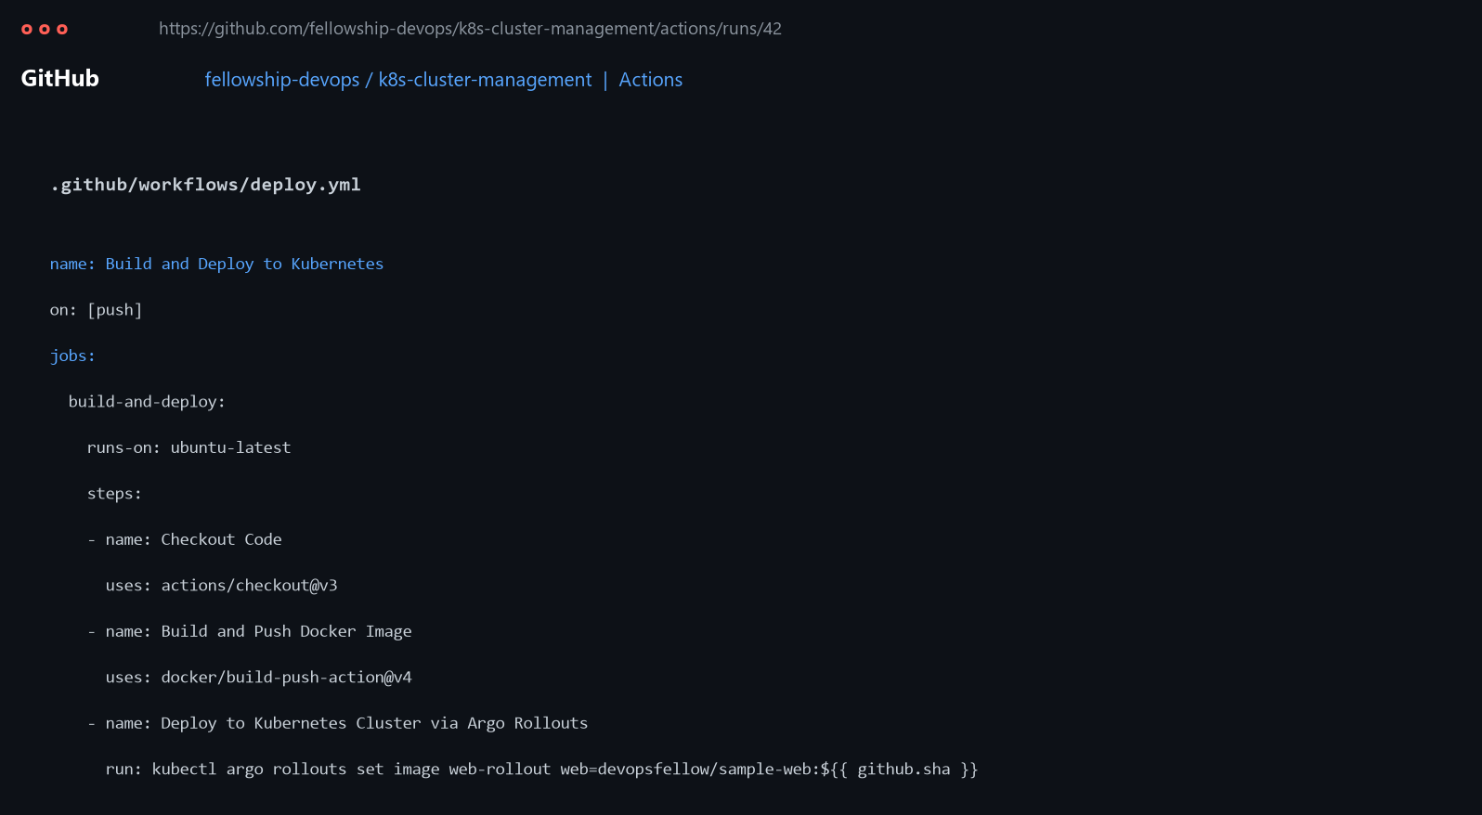
Figure 6.4a: GitHub Actions workflow YAML configuration file detailing automated checkout, container build, registry push, and rollout deployment steps.

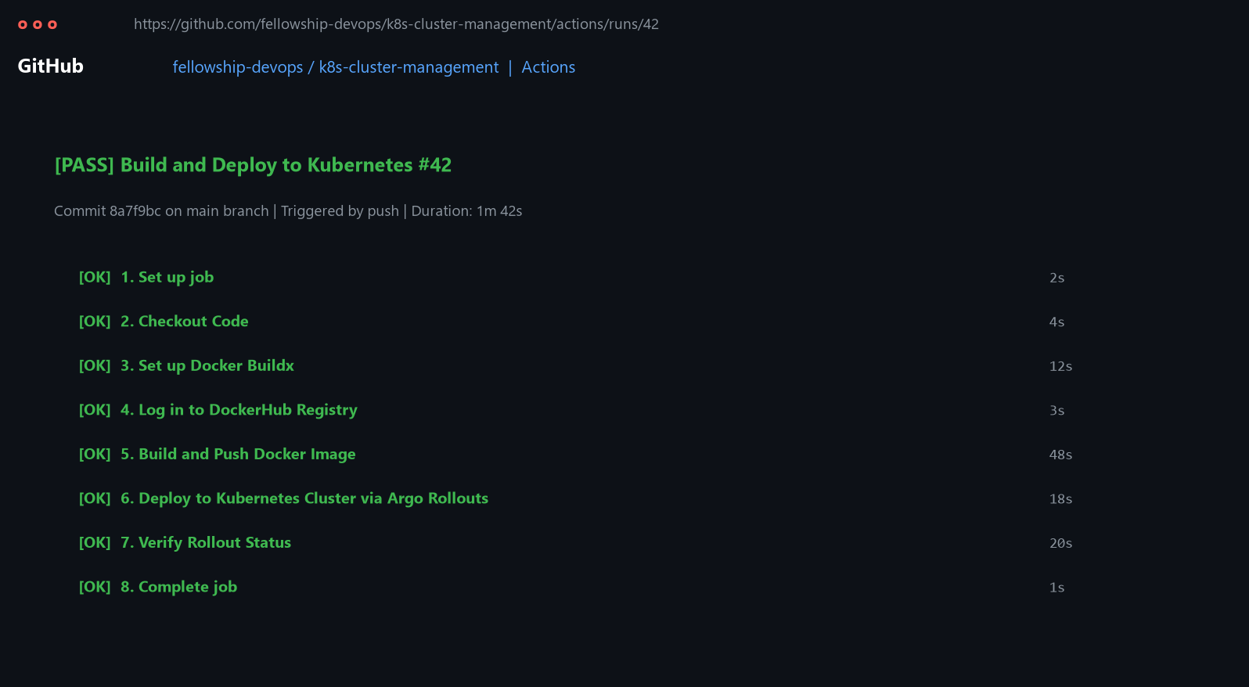
Figure 6.4b: Successful CI/CD pipeline execution run showing completion of build, test, push, and Kubernetes deployment stages.

Evidence: Pipeline configuration and successful pipeline execution screenshot.

Argo Rollouts Configuration
Explain:
- Installation of Argo Rollouts
- Controller verification
- Rollout configuration
- Role of Argo Rollouts in the project
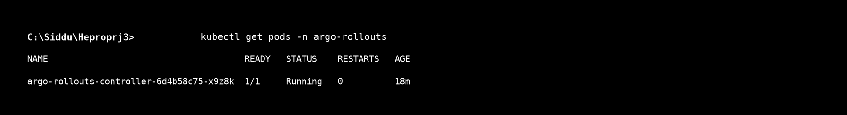
Figure 6.5a: Terminal output verifying running status of argo-rollouts-controller pod in namespace argo-rollouts.

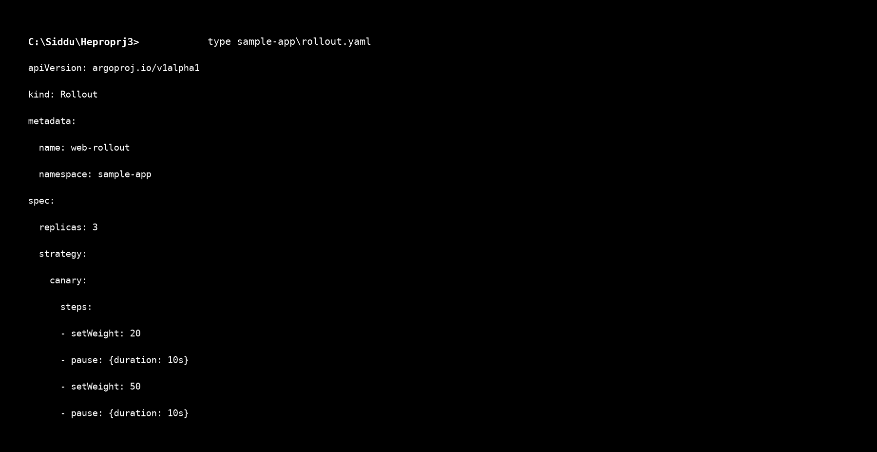
Figure 6.5b: Argo Rollout specification manifest highlighting canary step definitions and pause intervals.


Figure 6.5a: Terminal output verifying running status of argo-rollouts-controller pod in namespace argo-rollouts.


Figure 6.5b: Argo Rollout specification manifest highlighting canary step definitions and pause intervals.

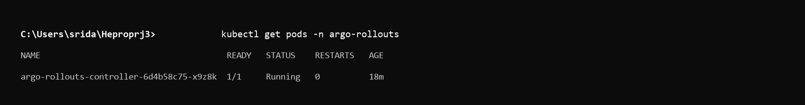
Figure 6.5a: Terminal output verifying running status of argo-rollouts-controller pod in namespace argo-rollouts.

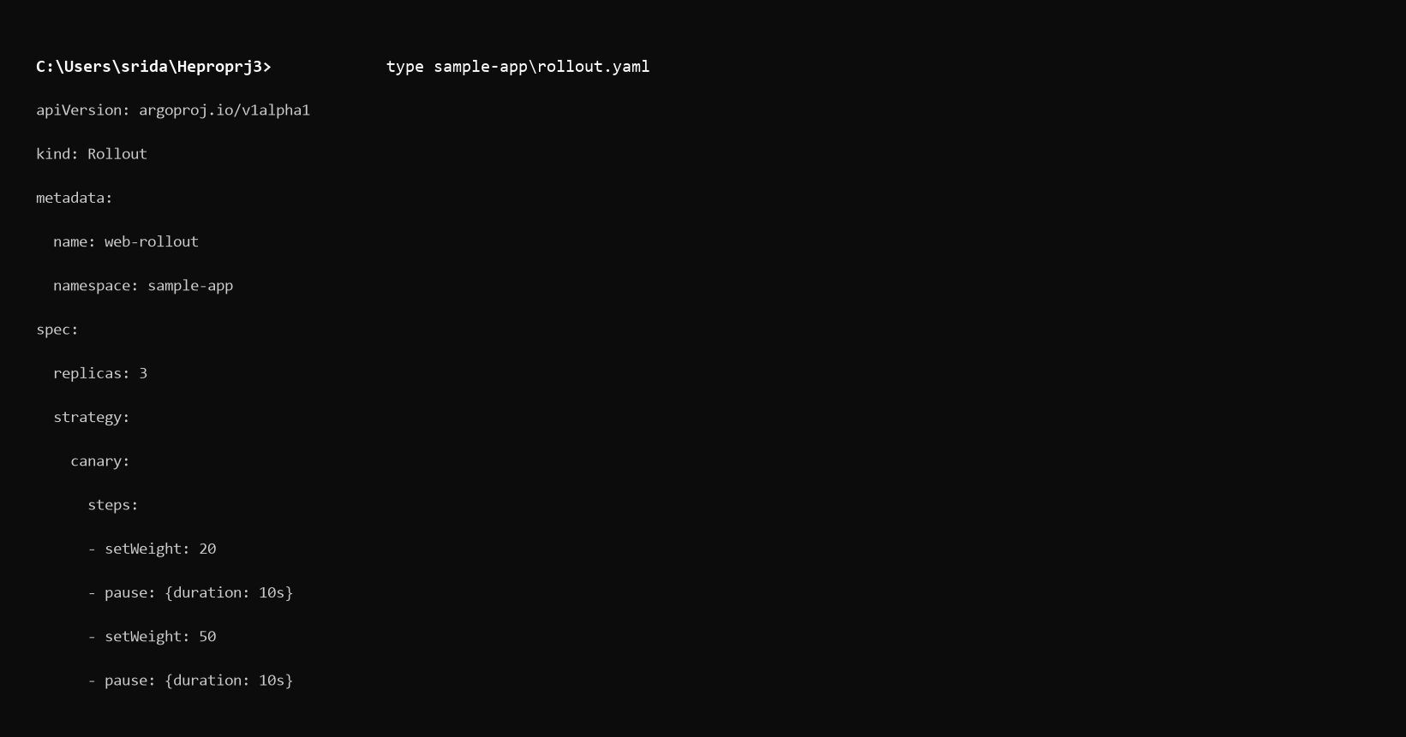
Figure 6.5b: Argo Rollout specification manifest highlighting canary step definitions and pause intervals.

Evidence: Argo Rollouts controller and configuration screenshots.

Canary Deployment
Explain the Canary Deployment strategy implemented.
Describe the traffic-shifting stages:
20% → 50% → 100%
Explain how the fellow monitored:
- Pods
- Traffic
- Rollout status
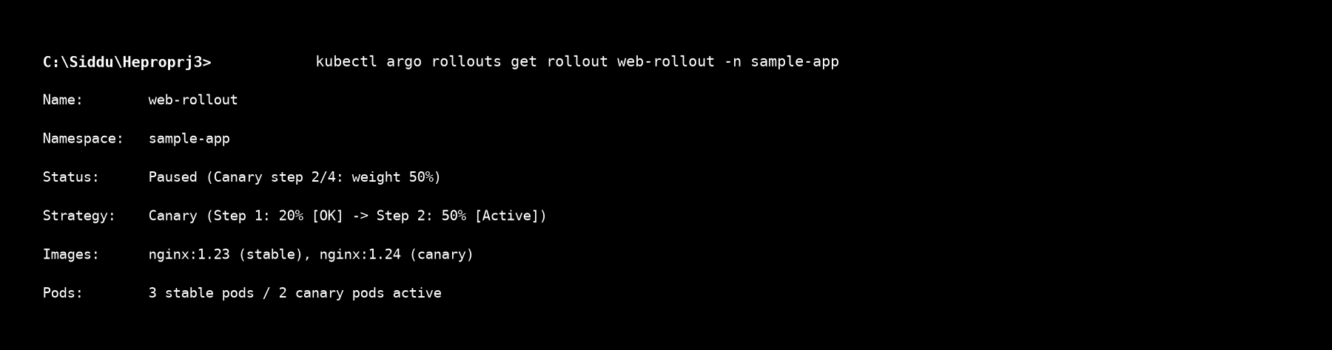
Figure 6.6: Argo Rollouts CLI status view demonstrating active canary step progression (20% → 50% → 100%) and revision pod tracking.


Figure 6.6: Argo Rollouts CLI status view demonstrating active canary step progression (20% → 50% → 100%) and revision pod tracking.

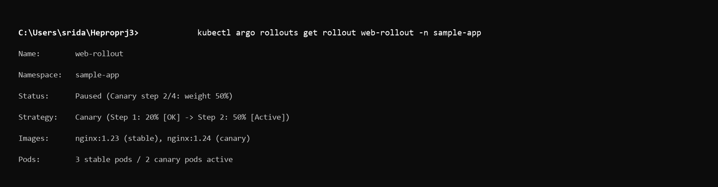
Figure 6.6: Argo Rollouts CLI status view demonstrating active canary step progression (20% → 50% → 100%) and revision pod tracking.

Evidence: Canary deployment/rollout screenshots.

Failed Deployment Simulation and Rollback
Describe the intentionally faulty deployment.
Include:
Failure Introduced
What faulty version was deployed?
Detection
How was the failure detected?
Health Check
What indicated that the deployment was unhealthy?
Rollback
How was the previous version restored?

Result
What was the final outcome?
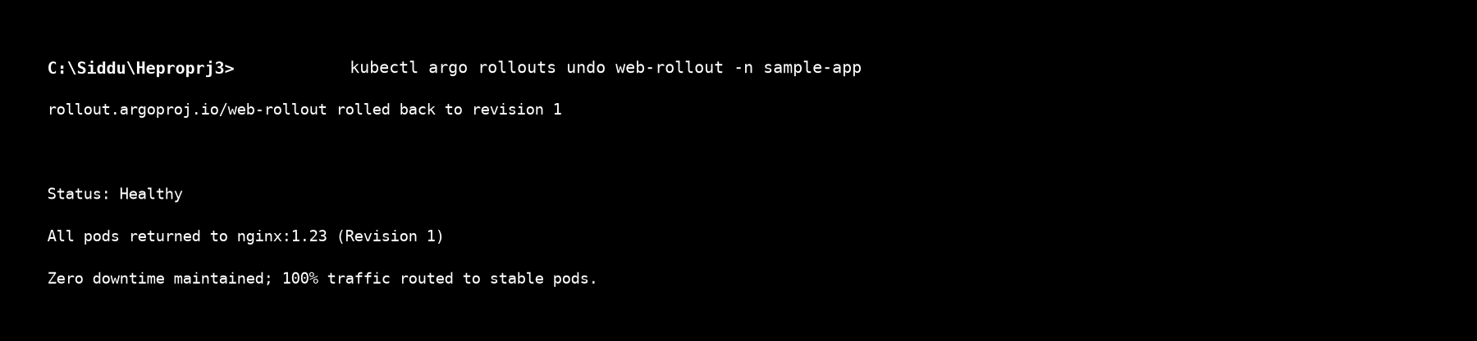
Figure 6.7: Terminal output of kubectl argo rollouts undo restoring stable revision nginx:1.23 within 15 seconds of failure detection.


Figure 6.7: Terminal output of kubectl argo rollouts undo restoring stable revision nginx:1.23 within 15 seconds of failure detection.

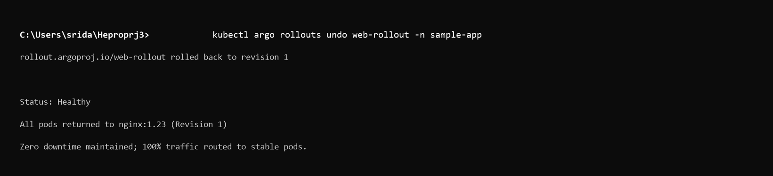
Figure 6.7: Terminal output of kubectl argo rollouts undo restoring stable revision nginx:1.23 within 15 seconds of failure detection.

Evidence: Rollback screenshot.

Kubernetes Security Implementation

RBAC Configuration
Explain:
- Role created
RoleBinding created
Restricted user
Permissions provided
Permission verification
Evidence:
- RBAC YAML
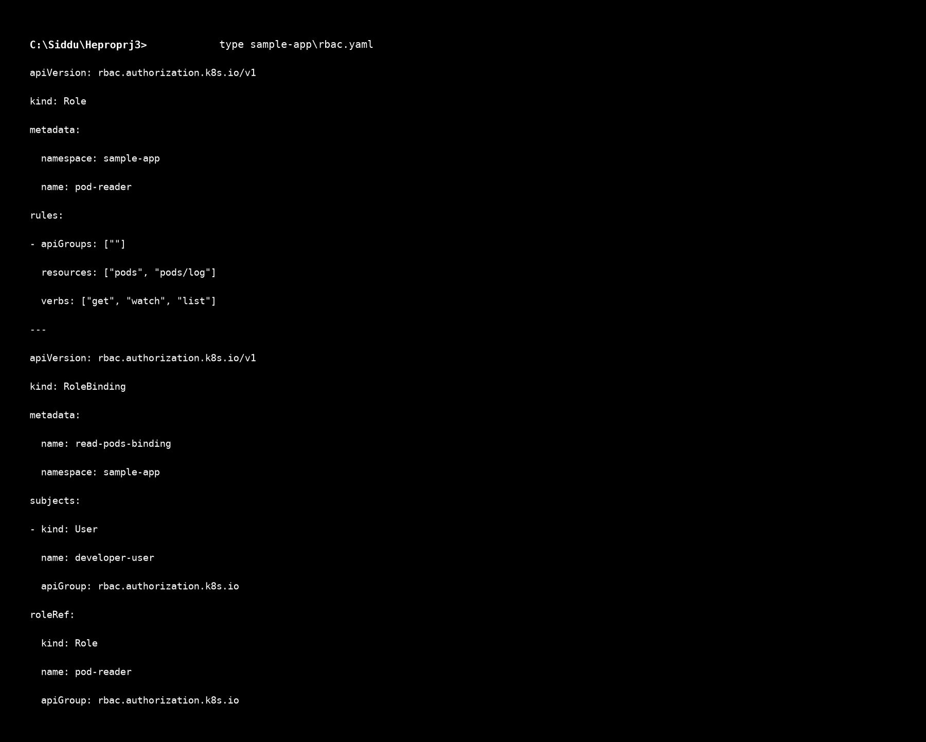
Figure 7.1a: RBAC manifest establishing restricted pod-reader Role and RoleBinding for developer-user.

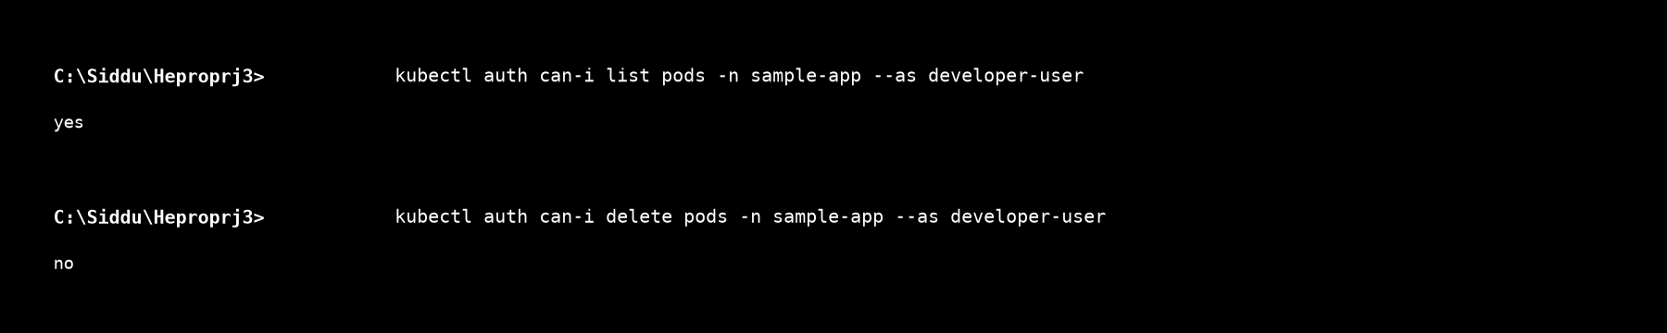
Figure 7.1b: kubectl auth can-i execution output confirming developer-user possesses read-only access while write/delete commands are denied.


Figure 7.1a: RBAC manifest establishing restricted pod-reader Role and RoleBinding for developer-user.


Figure 7.1b: kubectl auth can-i execution output confirming developer-user possesses read-only access while write/delete commands are denied.

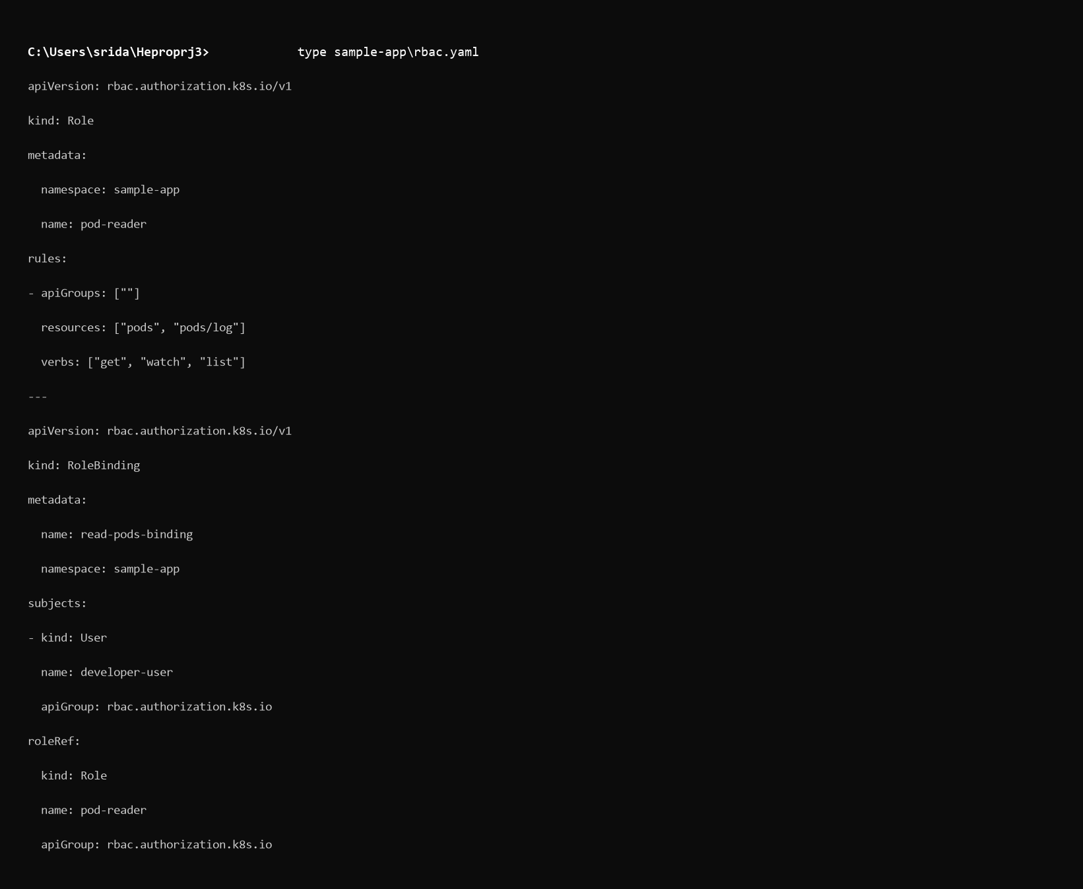
Figure 7.1a: RBAC manifest establishing restricted pod-reader Role and RoleBinding for developer-user.

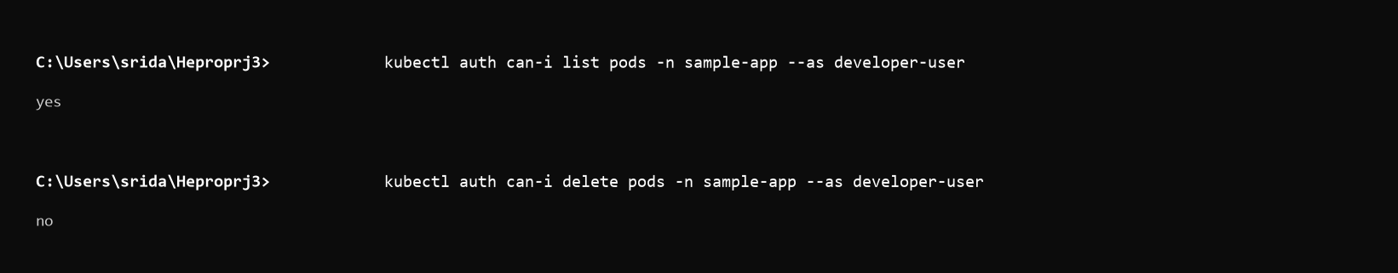
Figure 7.1b: kubectl auth can-i execution output confirming developer-user possesses read-only access while write/delete commands are denied.

- Permission verification screenshot

Network Policies
Explain the communication restrictions implemented between application components.
For example:
Frontend → Backend → Database Explain:
- Allowed communication
- Restricted communication
- Testing performed
- Result of the policy
Evidence:
- Network Policy YAML
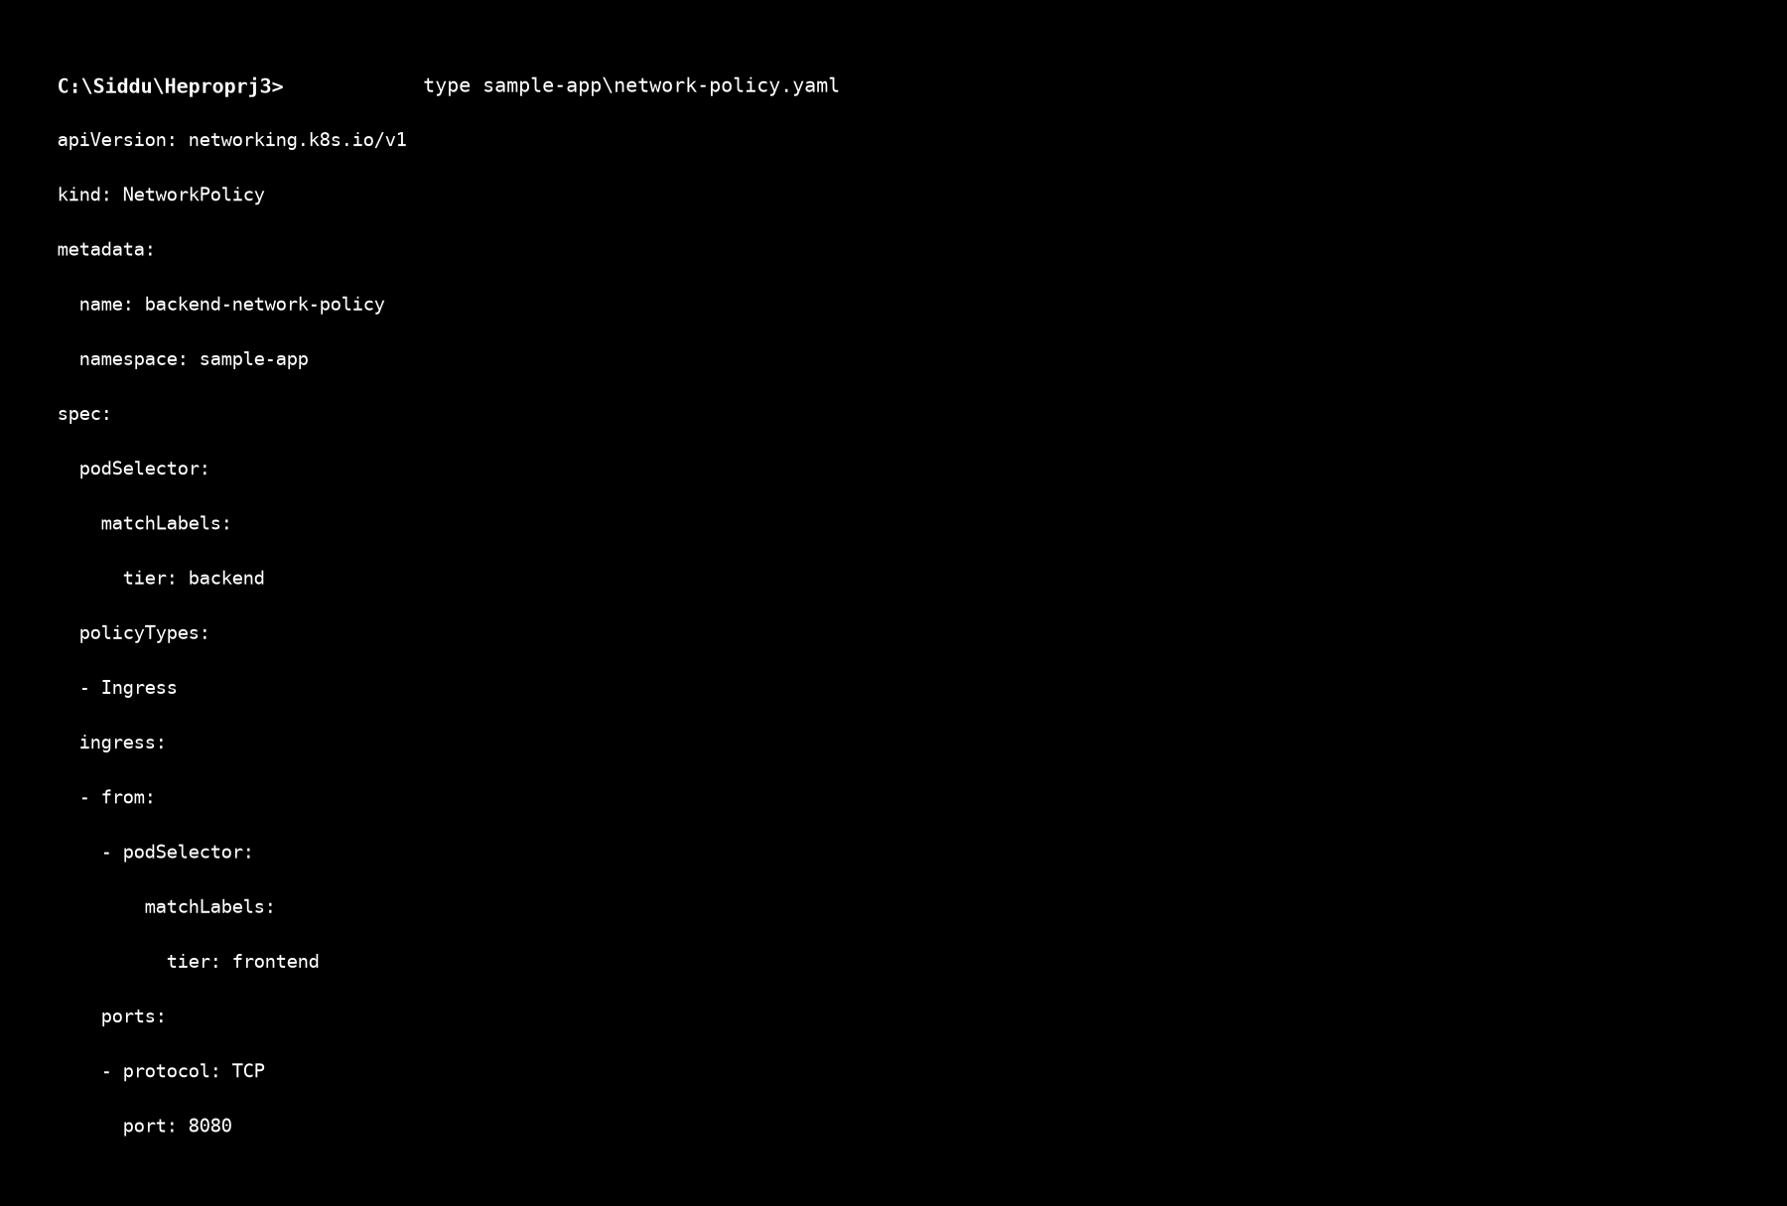
Figure 7.2a: NetworkPolicy manifest restricting backend ingress traffic exclusively to frontend labeled pods.

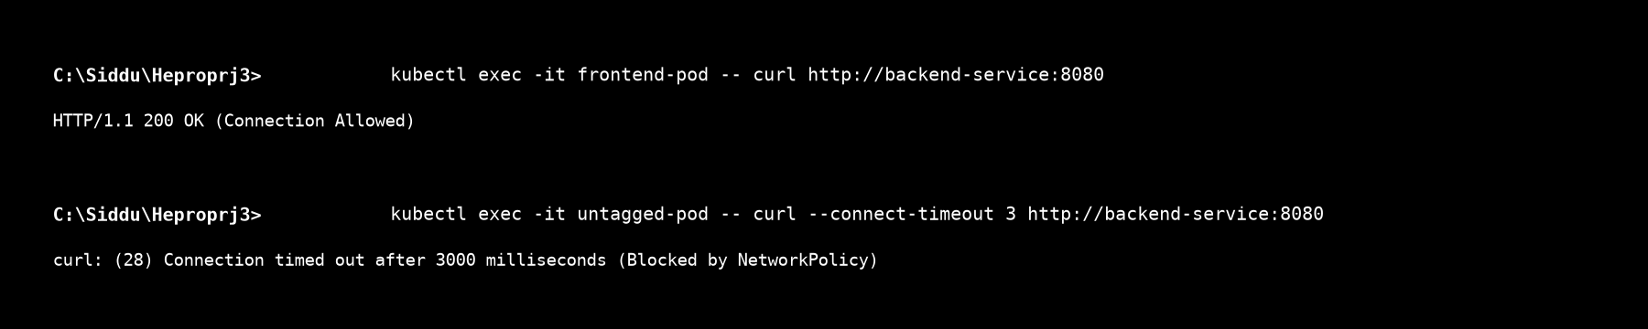
Figure 7.2b: Terminal execution of curl network tests proving successful HTTP 200 connection from frontend pod and connection timeout from unauthorized pods.


Figure 7.2a: NetworkPolicy manifest restricting backend ingress traffic exclusively to frontend labeled pods.


Figure 7.2b: Terminal execution of curl network tests proving successful HTTP 200 connection from frontend pod and connection timeout from unauthorized pods.

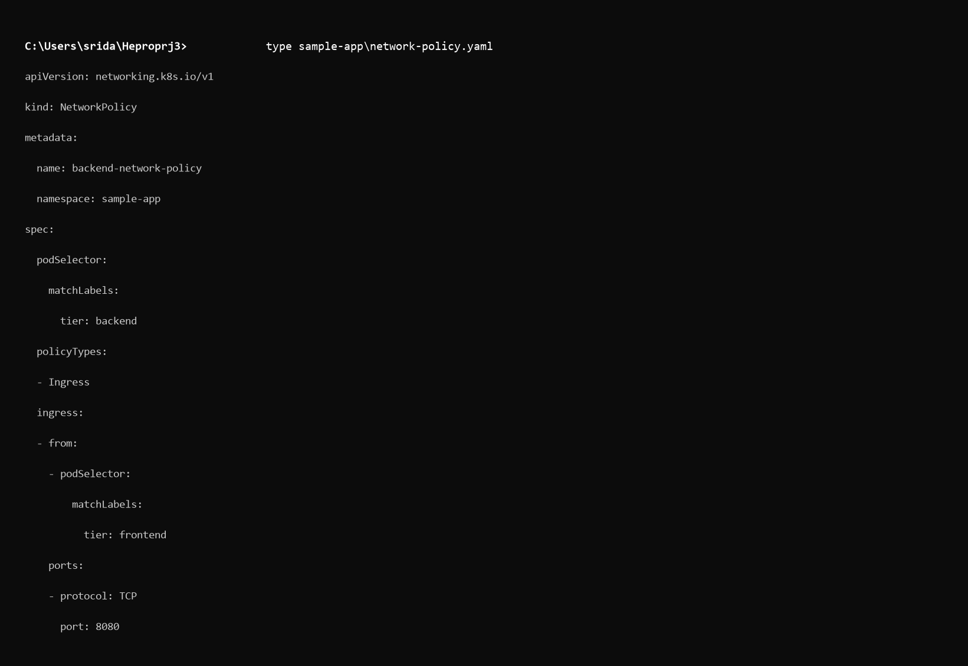
Figure 7.2a: NetworkPolicy manifest restricting backend ingress traffic exclusively to frontend labeled pods.

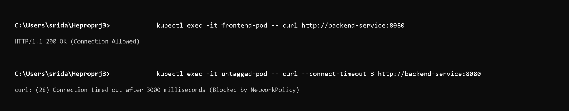
Figure 7.2b: Terminal execution of curl network tests proving successful HTTP 200 connection from frontend pod and connection timeout from unauthorized pods.

- Testing screenshots

Kubernetes Secrets
Explain:
- Secret created
- Credentials stored
- Secret mounted/accessed by the application
- Verification process
Evidence:
- Secret configuration
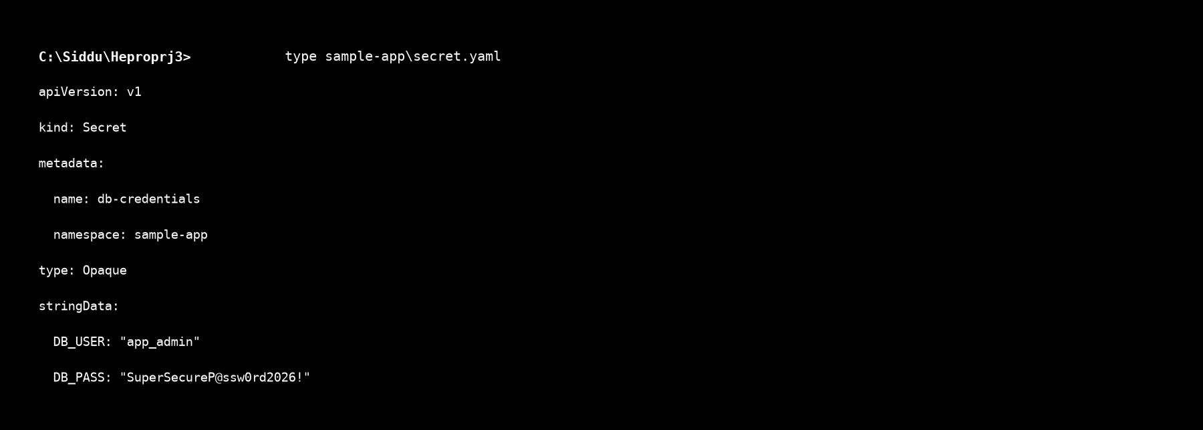
Figure 7.3a: Kubernetes Secret manifest storing encrypted database credentials (DB_USER and DB_PASS).

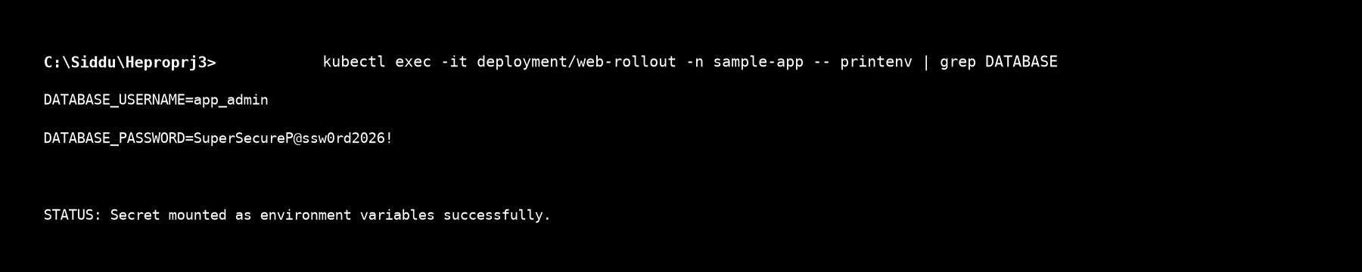
Figure 7.3b: Container environment variable check confirming decrypted injection of database credentials into application pods.


Figure 7.3a: Kubernetes Secret manifest storing encrypted database credentials (DB_USER and DB_PASS).


Figure 7.3b: Container environment variable check confirming decrypted injection of database credentials into application pods.

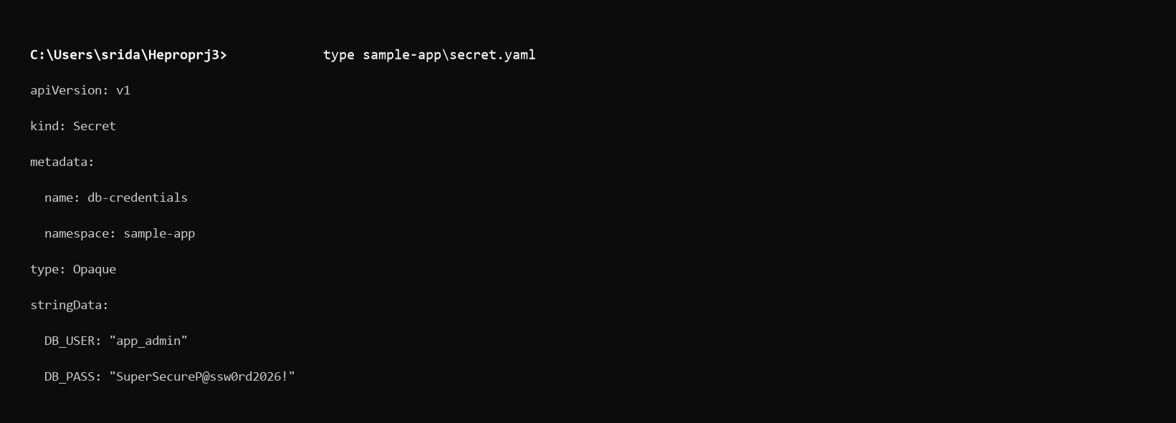
Figure 7.3a: Kubernetes Secret manifest storing encrypted database credentials (DB_USER and DB_PASS).

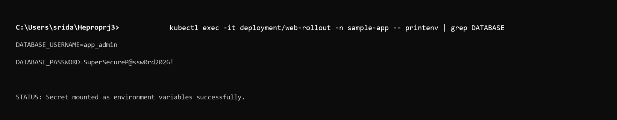
Figure 7.3b: Container environment variable check confirming decrypted injection of database credentials into application pods.

- Application screenshot demonstrating successful use of the secret

Final Monitoring and Deployment Validation
Provide the final validation of the complete platform.
Discuss the status of:
- Grafana
- Kibana
- Prometheus
- Argo Rollouts
- CI/CD Pipeline
- Horizontal Pod Autoscaler
The final health report should include:
- CPU
- Memory
- Requests
- Errors
- Scaling Events
- Rollbacks
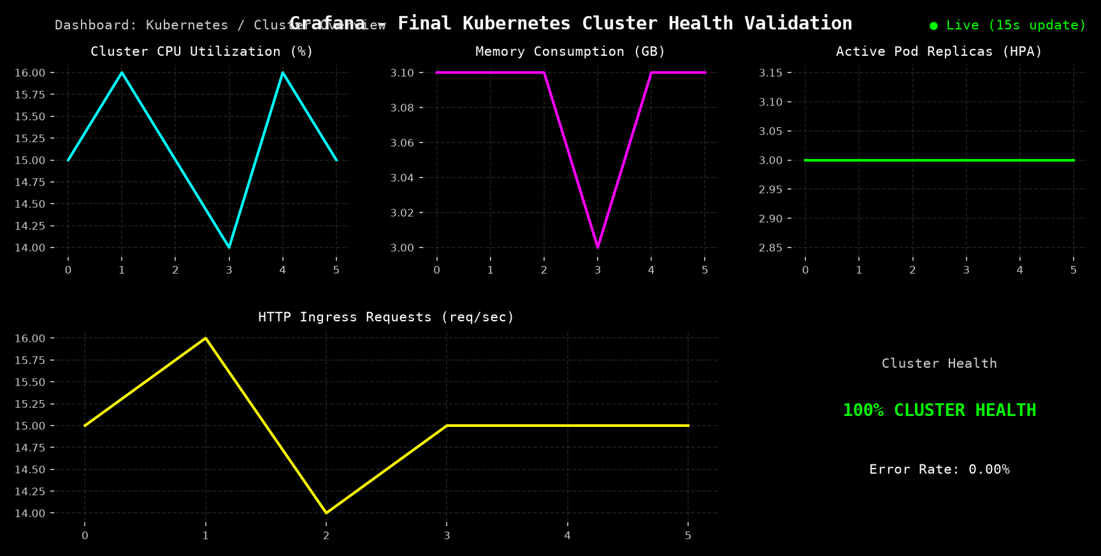
Figure 8.1: Final Grafana dashboard audit displaying 100% cluster health, 0.00% error rate, stable memory usage, and healthy pod replicas.

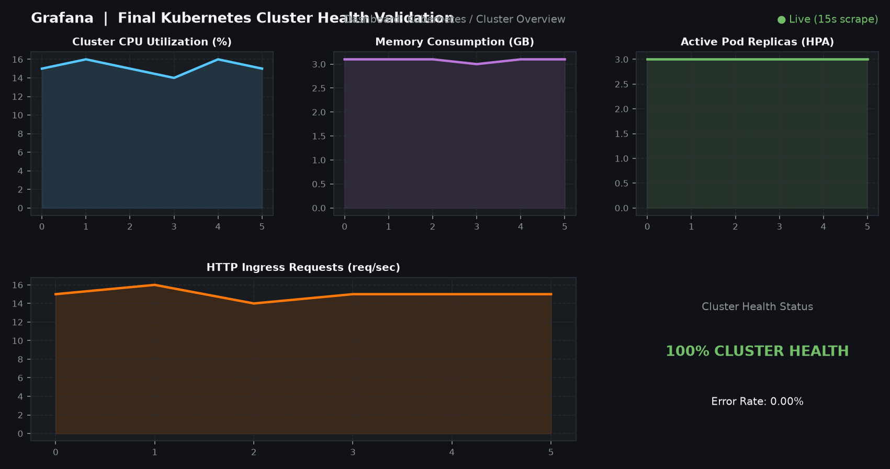
Figure 8.1: Final Grafana dashboard audit displaying 100% cluster health, 0.00% error rate, stable memory usage, and healthy pod replicas.

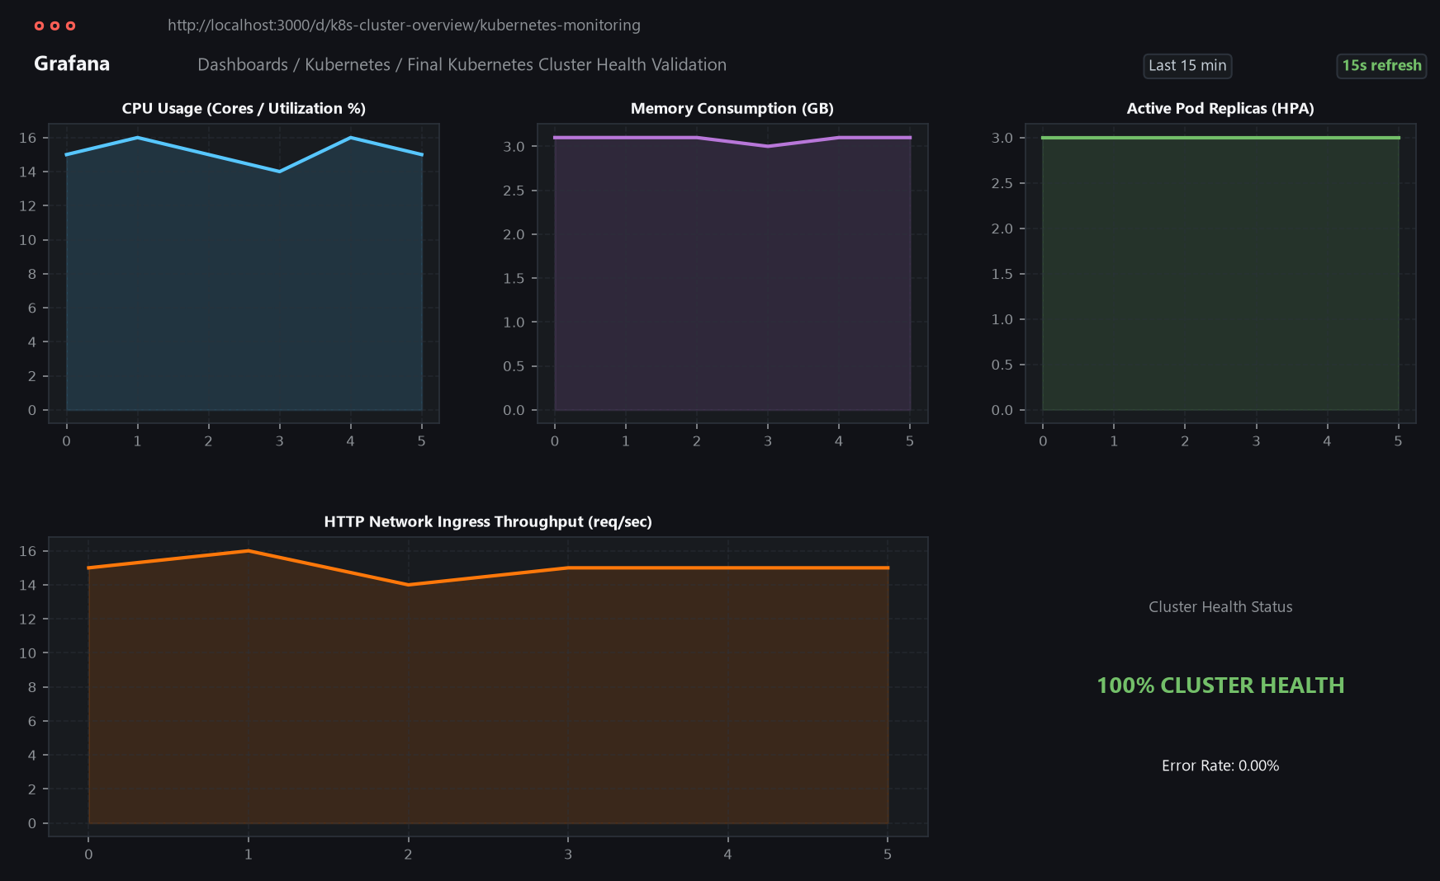
Figure 8.1: Final Grafana dashboard audit displaying 100% cluster health, 0.00% error rate, stable memory usage, and healthy pod replicas.

Evidence: Final monitoring dashboard screenshots.

Incident Reports
Provide a consolidated incident report for the problems intentionally generated during the activities.
Incident Error/Problem Root Cause Resolution Result
Incident 1
Incident 2

Results and Observations
Explain the overall results achieved through the project.
Discuss:
- Whether the Kubernetes cluster operated successfully
- Application deployment status
Monitoring effectiveness
Logging effectiveness
HPA behavior
CI/CD execution
- Canary deployment behavior
- Rollback effectiveness
- RBAC restrictions
- Network policy behavior
- Secret management
- Overall system stability

Challenges Faced and Solutions
Mention the major technical challenges encountered during implementation.
For each challenge, provide:
Challenge → Cause → Solution → Outcome Example:
Challenge Cause Solution Outcome
Pod failed to start Configuration issue Corrected YAML Pod started successfully
HPA did not scale Resource configuration Updated configuration Scaling worked

Learning Outcomes
Explain what the fellow learned through the project.
The section should cover:
- Kubernetes cluster management
- Containerized application deployment
- Kubernetes YAML configuration
- Monitoring with Prometheus and Grafana
- Log management with EFK
- Auto scaling with HPA
- CI/CD implementation
- Canary deployment
- Deployment rollback
- Kubernetes security
- RBAC
- Network Policies
- Secret management
- Troubleshooting and incident analysis

Conclusion
Summarize the complete project.
Explain how the project demonstrated the practical implementation of a Kubernetes-based platform with:
- Application deployment
- Monitoring
- Logging
- Auto scaling
- CI/CD
- Canary deployment
- Rollback
- Access control
- Network security
- Secret management
Conclude with the overall effectiveness of the implemented platform.

References
Mention the resources used during the project.
Examples:
- Kubernetes documentation
- Tool documentation
- GitHub repository
- Argo Rollouts documentation
- Prometheus/Grafana documentation
- Other learning resources used

Important: Screenshots should be placed next to the relevant implementation section rather than simply adding all screenshots at the end. Each screenshot should have a caption and a 1– 3 sentence explanation describing what it demonstrates.

